For Sale Zenair CH701

1 400 000 THB o.n.o

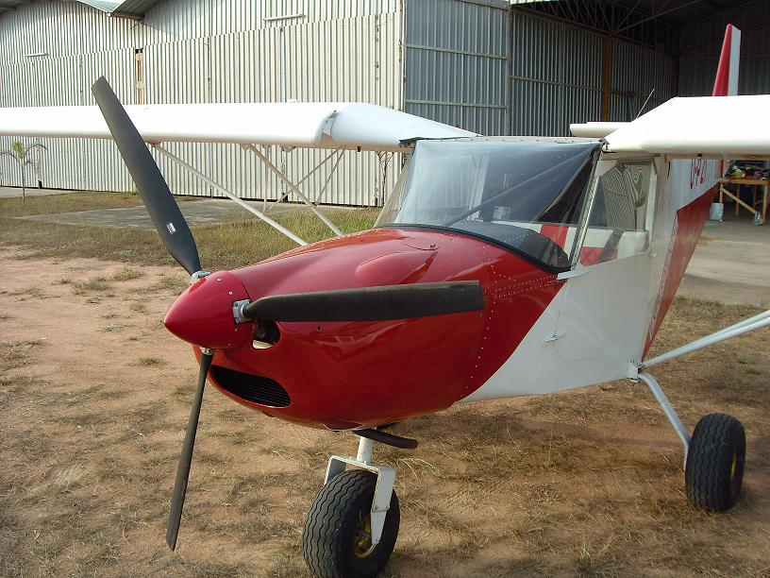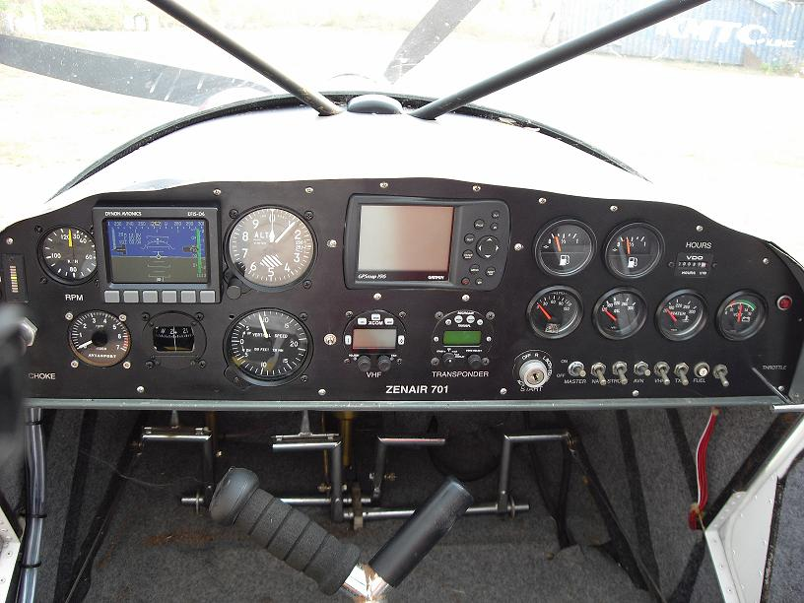

Airframe Ex Czech Republic 100% airframe built. Originally sold to Canada then operated in the USA for 2 years. Imported to Thailand in 2005, then first registered and flown in Thailand in 2008.
Cowling is the new Czech style. Currently registered and operating with a C of A and 5 yr. Permit.
Engine Rotax 912 ULS 100 hp. Total time just less than 100 hrs. Instruments are the typical Rotax instruments: tachometer, oil temperature & pressure, coolant temperature, fuel gauges, ammeter and hobbs meter. New fuel lines and hoses Nov 2010.
Dynon EFIS D6 Attitude, remote fluxgate compass, barometric altitude, airspeed, vertical speed and angle of attack option. Backup instruments are analogue airspeed, altimeter and vertical airspeed indicators, which are independent from Dynon. Whisky compass: flush panel installed.
GPS Garmin 196, flush installation. Panel is anodized in black with circuit breakers switches.
Radio MOC licensed VHF Xcom 760 with intercom and 121.5 Mhz emergency channel priority. PTT on the stick. Co-pilot PTT included in the wiring harness - can be fitted on the stick or panel.
Transponder MOC licensed Microair Mode C with altitude encoder.
Flapperons: manual single setting: Trim: electric trim, stick control with panel LED indicator.

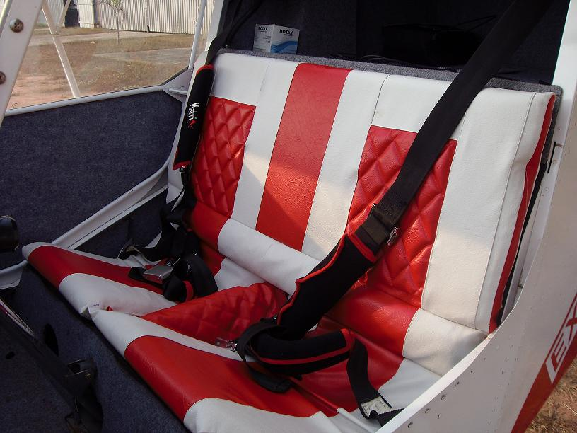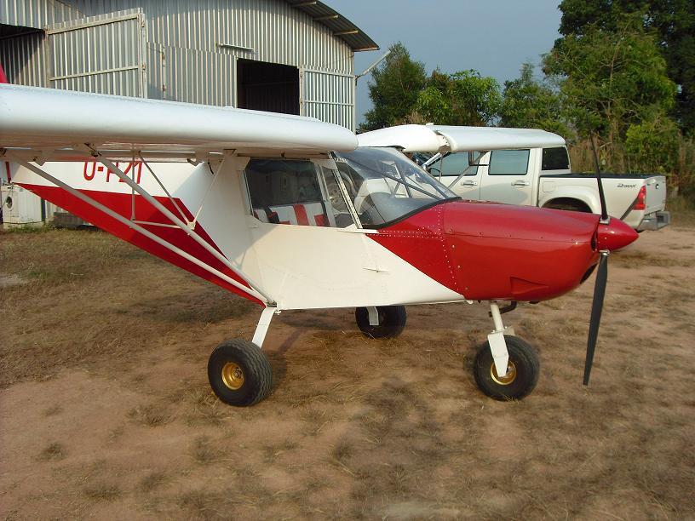

Contact: Gerry Lategan Telephone 0871 404 174 or e-mail gerry@gerrylategan.com.

The aircraft is registered as U-P21 and is located at Eastern Airfield, Pattaya, Thailand.

