aircraft hydraulics
Aircraft Hydraulics is a means of transmitting energy or power from one place to another efficiently.
What is hydraulic technology?
In the hydraulic technology we transmit and control forces and velocities by transmitting and controlling pressure and flow. In nearly every kind of technology we use hydraulic drive and control techniques. A few examples are:
mechanical engineering
car technology
agriculture technology
earthmoving and mining technology
ship building technology
offshore-technology
aircraft and spacecraft technology

Advantages of Hydraulic Systems
(over other systems for aircraft use)
It is lighter in weight than alternate existing systems.
It is dead beat, that is, there is an absence of sloppiness in its response to demands placed on the system.
It is reliable; either it works or doesn't.
It can be easily maintained.
It is not a shock hazard; it is not much of a fire hazard.
It can develop practically unlimited force or torque.
Example: A gun turret must be able to change direction almost instantaneously. This is what is accomplished by this hydraulic system. In an electrical system, the rotating armature must come to full stop and then reverse direction or else the armature will burn out. This doesn't happen with a hydraulic system because there is no need for a motor in the hydraulic system.
Example: In a landing gear the hydraulic motor can produce enough power to pull up the landing gear system without trouble even though air loads act on the system and the slip stream air is impinging against it.
The actuating cylinder can change hydraulic power to linear or rotating motion. It has a reduction gear in it to reduce rotating motion to that amount which is needed. Previously, systems used to control motion by using steel cables connected by pulleys between the controlling mechanism (such as the pedals) and the controlled surface (such as the rudder). The cables were affected by expansion rates of the cables due to temperature changes. Hydraulic systems can control motion without worrying about the effect of temperature since it is a closed system (not open to the atmosphere) compared to a cable system. This means better control of the plane and less lag time between the pilot's movement to control the plane and the response by the control surface.

Some Devices Operated by Hydraulic Systems in Aircraft
Primary control boosters
Retraction and extension of landing gear
Sweep back and forth of wings
Opening and closing doors and hatchways
Automatic pilot and gun turrets
Shock absorption systems and valve lifter systems
Dive, landing, speed and flap brakes
Pitch changing mechanism, spoilers on flaps
Bomb bay doors and bomb displacement gears
hydraulics systems principles of operation

Introduction
Pressures in hydraulic systems can be extremely high and normally are measured in thousands of pounds per square inch (psi) when using British units of measurement, or Pascals (Newtons/square meter).
Part of the hydraulic system is the actuating cylinder whose main function is to change hydraulic (fluid) power to mechanical (shaft) power. Inside the actuating cylinder is a piston whose motion is regulated by oil under pressure. The oil is in contact with both sides of the piston head but at different pressures. High pressure oil may be pumped into either side of the piston head.
In following animation, an actuating cylinder controlled by a selector valve. The selector valve determines to which side of the actuating cylinder the high pressure oil (red coloured side) is sent. The piston rod of the actuating cylinder is connected to the control surface, in this case, an elevator.
As the piston moves out, the elevator moves down. As the piston moves in, the elevator moves up. The selector valve directs the high pressure oil to the appropriate side of the piston head causing movement of the piston in the actuating cylinder. As the piston moves, the oil on the low pressure side (blue coloured side) returns to the reservoir since return lines have no pressure!
The differential in oil pressure causes movement of the piston. The force generated by this pressure difference can be sufficient to move the necessary loads. Each cylinder in the plane, boat, etc., is designed for what it must do. It can deliver the potential it was made for; no more, no less. Air loads generally determine the force needed in aircraft applications. For example, if a force of 40,000 pounds is required and the high pressure oil is pumped in at a pressure of 1000 psi, then the piston is designed to have a surface area of 40 square inches on which the oil acts.
Press 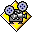to see Animation
Your browser does not support inline frames or is currently configured not to display inline frames.
If you don't see the animation, click here to download Macromedia ShockwavePlayer.

Hydraulic System
A hydraulic system transmits power by means of fluid flow under pressure. The rate of flow of the oil through the system into the actuating cylinder will determine the speed with which the piston rod in the actuating cylinder extends or retracts. When the cylinder is installed on the aircraft, it is already filled with oil. This insures that no air bubbles are introduced into the hydraulic system, which can adversely affect the operation of the system.

Pascal’s Theory
The method by which fluid is used to create force was explained by Pascal. In a confined stationary liquid, neglecting the effect of gravity, pressure is distributed equally and undiminished in all directions; it acts perpendicular to the surface it touches. Because the actuating cylinder is not vented, the force delivered through the piston to the surface of the fluid is translated into a pressure on the surface of the fluid.
The pressure (p) acting on the incompressible oil does work [(pressure) x (Area of piston) x (piston's stroke) = Work]. In the diagram below, the force acting on the right side piston does work and moves the fluid from the right cylinder to the left cylinder. The fluid movement into the left cylinder creates a pressure on the left piston's surface area. That in turn creates a force that moves the left piston up.

Multiplication of Forces
Pascal's Law states that the pressures in both cylinders are the same (p1=p2). Thus, given a force, F1, of 10 pounds (lbs) in the right cylinder acting on a piston area, A1, of 2 square inches (sq. in.) a pressure in the right cylinder, p1, of 5 pounds per square inch (lbs/sq. in. = psi) is produced. Now if A2 is given as 5 sq. in., then the force developed in the left cylinder is F2 = p2xA2, or 25 lbs. This is due to the fact that p1=p2. Thus Pascal's Law shows the way in which one can increase the output force for a given input force...regulate the areas of the pistons!
The only disadvantage is the size of the piston stroke involved. Let's say, piston 2 moves (up) 10 inches. For the previous problem the work done by piston 2 is F2 times the stroke of piston 2 (10 in. x 25 lbs). If no losses exist in the system due to friction, then work is conserved and piston 1 must do 250 in-lb of work. Therefore, the F1 must move down 25 inches (250 in-lbs/10 lb force)! To move piston 2 up, a volume of 50 cubic inches (cu. in.) of incompressible oil must be pumped in at 5 psi (since pressure times Volume is also another way to find work). The movements of the pistons are measured relative to the bottom of the cylinder with all the measurements computed to produce 100 % efficiency.
Press to see Animation
Your browser does not support inline frames or is currently configured not to display inline frames.

How to Increase the Output Force of Cylinder 2
- Increase the pressure generated.
The disadvantage with this idea is that you must remove the old tubing and replace it with new tubing that can withstand the new loading.
- Increase the area of piston 2.
That may be restricted by the size of the actuating cylinder you can place in the location slated for the cylinder.
- Increase the stroke of piston 1.
This may also be restricted by the location of the actuating cylinder 1.

How to Increase Input Force, F1
- Increase the force by increasing the pressure.
- Increase the stroke of piston 1.
- Decrease the area of piston 2.
Just to reinforce what was said before: the distance of piston movement for the piston in the output cylinder is determined by the volume of oil being pushed into the output cylinder.

Brake System in a Car – Hydraulic System
An example of a hydraulic system that we deal with every day is the brake system in our cars. That system is an example of the material we have just discussed. Look at the picture given below. When the brake pedal is pressed down, the piston in the 1st cylinder goes down, pushing the oil through the tubing into the little wheel actuating cylinder near the brake shoes. The oil, in turn, pushes the little pistons out and this, in turn, pushes the shoes up against the brake drum causing the car wheel to be slowed to a stop.
Press to see Animation Your browser does not support inline frames or is currently configured not to display inline frames.
pressure regulation in hydraulic systems

Introduction
If a system relief valve (SRV) were used to regulate pressure, it would have to be replaced in a very short time. This would be due to the overuse of the SRV and the failure of the spring's elasticity. If the SRV were used, the oil pushing on the spring-ball combination would cause tremendous vibrations and heat would be dissipated by the oil under high pressure attempting to push the ball away from the seat to get to the low pressure side.

Douglass Pressure Regulator
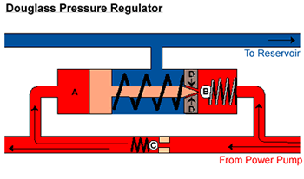
When an actuating cylinder finishes its motion and stops, a high pressure will be felt through the system. If so, this high pressure oil coming from the power pump (right side of diagram) will keep check valve C open and also act on piston A. In its movement, piston A pushes Ball B off seat D. The oil, taking the passage of least resistance, goes through passage D into the center chamber (colored blue) back to the reservoir. The pressure on the right side of check valve C will drop and will be less than the pressure on the left side of C, therefore, causing the ball to seat itself in check valve C. When the hydraulic system pressure drops, the pressure on piston A decreases, causing a decrease in pressure on B as well. The path of least resistance through D will close and the oil will move in the direction towards check valve C. Now, because the pressure on the right side of C is greater than on the left of C, the check valve will be forced open and the oil will move toward the selector valve side of the system (left side of diagram).
The range of operation of the pressure regulator is defined by the difference in force required for bypass and the force required at actuation.
Electrol Pressure Regulator
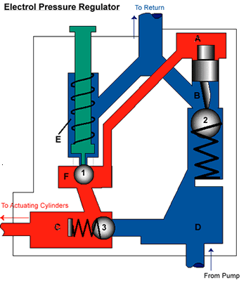
The dual purpose of a pressure regulator is to reduce the load on the hydraulic pump when not needed and to keep the hydraulic pressure within the operating range of the hydraulic system.
When the hydraulic pump is charging the system, balls 1 and 2 are seated on their seats but ball 3 is letting oil pass through to the actuating cylinders. When actuation stops, the pressure in the system builds to maximum. The spring holding ball 1 onto the lower seat is designed to withstand the force produced by the maximum pressure of the hydraulic system. As maximum pressure is reached, ball 1 is made to move to the upper seat, thereby letting high pressure oil reach the A side of piston. But, ball 3 has already moved to its seat due to the higher pressure felt on side C than on side D. Therefore, oil coming from the hydraulic pump is at a charging pressure less than the maximum pressure of side A of the piston, causing the piston to move down, in turn pushing ball 2 down. Oil, wanting to take the path of least resistance, goes by ball 2 to the return line.
If actuation restarts, then pressures at C side of ball 3, at A side of piston and at F side of ball 1 decreases. Ball 1 falls onto the lower seat, since the spring force is greater than the force generated by the hydraulic system's oil pressure. Piston A will then move up due to the pressure drop on side A, causing ball 2 to close the orifice to the return line. The oil being pumped from the hydraulic pump now has greater pressure on side D of ball 3, causing the ball to move to the left and the hydraulic system oil goes in the direction of the actuating cylinder.
The range of operation depends on ball 1. As you can see, if the force of the spring holding ball 1 is to be overcome, a certain pressure (equal to the spring force divided by the opening's cross-sectional area) at the lower seat would be needed. If the ball were to move upward to the upper seat, the exposed surface area of the ball on which the pressure acts would increase (while the spring force would essentially remain the same) thereby causing the pressure in the system to decrease. Ball 1 would then move from the lower seat to the upper seat very quickly as more surface area is exposed, causing the pressure required to move the ball to drop. When the pressure delivered is much higher than the pressure required to move the ball, then the ball will move quickly and bang shut against the upper seat. The opposite reaction occurs when the pressure in the system is lowered to within operational limits.
aircraft hydraulic system reservoir design
Functions of the Reservoir
Provides air space for expansion of the oil due to temperature changes
Holds a reserve supply of oil to account for
thermal contraction of oil.
normal leakage - oil is used to lubricate piston rods and cylinder seals. When the piston rod moves, it is scraped to remove impurities that might collect on the rod when returning into actuating cylinders. If many actuating cylinders are operating at the same time, then the amount of oil lost is greater.
emergency supply of oil - this case occurs only when the hand pump is used.
volume changes due to operational requirements - oil needed on side 2 of piston head is less than that needed on side 1 of cylinder piston (which occurs during actuation).
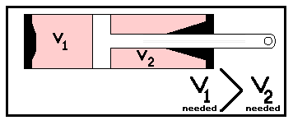
Provides a place to remove air or foam from liquid.
Provide a pressure head on the pump, that is, a pressure head due to gravity and depends upon the distance of the reservoir above the power pump.
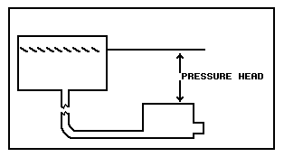

Construction of Reservoir
In the construction of a reservoir, one must know:
Material: for the reservoir itself 5052 aluminium has been used. It is weldable and ductile, it can work in the needed temperature range and it must work when it is in any position and orientation to the earth (example: 1. In space, it is on its side; gravity is pulling on the reservoir's "sides"; 2. during blast-off, gravity is forcing the liquid to the tank's bottom.)
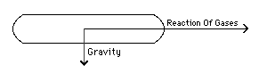
Example 1.
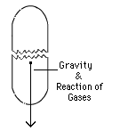
Example 2.
Size: To obtain the size of the reservoir needed, one must calculate the volume of oil needed for one emergency actuation. This means finding the amount of oil needed for all emergency equipment to work. Then, it is necessary to calculate the volume for thermal contraction by taking all oil volumes of the hydraulic system, finding the coefficient of contraction and multiplying it by the number of degrees in the temperature range expected during operation. You must do the same for all oil volumes in operational requirements, thermal expansion, leakage, etc.
Shape: You must look at the space available to fit the tank. A sphere is the best shape to use because uniform stresses are generated by the interior pressure. Its one major disadvantage is that it is difficult to mount. The next best shape is a domed cylindrical shape. Not only can it be mounted easily, but it can be made to order.
A stand pipe to the power pump is needed and is always in the middle of the tank. Regardless of variation in its orientation (upright or on its side), it will be submerged. The return pipe from the rest of the hydraulic system is put near the top of liquid in the tank, at a tangent to the tank surface, so that the fluid entering releases all its energy through swirling at the top and dissipates it through release of bubbles of
foam.
Baffles within the tank are used for two reasons:
- they strengthen the tank against pressure from within and outside of the tank, and, more importantly,
- they are used to stop the swirling effect of the return oil from producing a whirlpool. This effect would only make the stand pipe in the centre of the tank suck in the column of air.
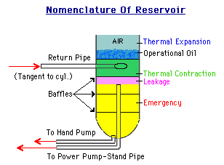
Filler pipe. Such a pipe eases the replenishing of the reservoir liquid. Since liquid seeks its own level, we put the filler pipe so that its mouth has the same level as the design level in the reservoir.
Vent to atmosphere- Initially, vents were introduced because a vent will not allow a void to form within the tank. However, as ceiling altitudes increased, pressure within the tank and the hydraulic system was being lost and cavitation occurred. To stop this phenomenon from happening, pressurized reservoirs were created (see section 1.7).
Dipstick-Sometimes filler pipes could not be used to add oil and tanks would have to be filled from the top. This made it difficult to measure the oil. The dipstick was therefore introduced. A long stick with marks on it, its job was to measure oil depth.
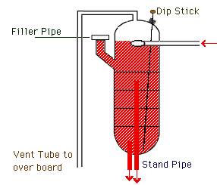
pressurized hydraulic reservoirs

Douglas Pressurized Reservoirs
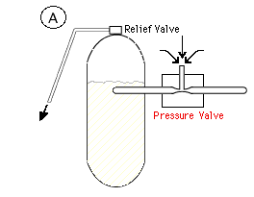

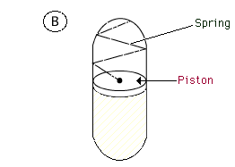
Here are two examples of the Douglass Pressurized Reservoir. In (A), a low pressure is created by the Venturi action of flowing oil. This would cause air to come in through pipe (1) to relieve the low pressure; and a pressure head would be formed. The relief valve on the vent at the top of the tank would regulate the pressure. In (B), the spring load and piston keep oil under constant pressure. This type of design is bad because you couldn’t fill the reservoir with oil easily.

Boot Strap (self-pressurizing) Reservoirs
Boot Strap reservoirs are used in spacecraft and are used to maintain positive pressure in the hydraulic lines. Actually, there is some return line back pressure since P₂ is greater than the return line pressure. For example, if the pressure line is at 500 psi and it acts on the 1 square inch piston surface (see figure below), the force generated would be 500 lb. Since the boot strap system incorporates piston 1 and piston 2 into a combined piston (see Pascal's Theory --Section 1.2), this force would be converted into a pressure, P₂, of 5 psi acting on the 100 square inch surface of the piston, A₂ .
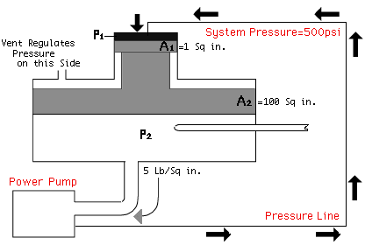
This type of reservoir is very difficult to maintain. Also, bubbles trapped within this system cannot be removed very easily. Its good points are that it is foamless and has no air which can be trapped in the fluid due to its operation.
cavitation
Cavitation occurs when a liquid (such as oil) moves within tubing or pipes at very fast speeds causing the absolute pressure of the liquid to drop drastically. This process occurs with little loss of heat. If the absolute pressure drops below the vapour pressure of the liquid, cavitation will form. This phenomenon is more serious in viscous liquids than in thin liquids. Cavitation causes separation of gases that are within the liquid (such as air or water vapour) from the liquid itself. Bubbles would form then collapse.
A measure of cavitation is the cavitation number
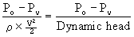
where Po is the absolute pressure Pv is the vapour pressure the denominator is the dynamic pressure head.
How could this occur in an airplane, you might ask. In the case of a liquid entering the suction side of a pump, the pressure would be low. For the liquid to move from one place to another, it would have to expend energy, thus causing a further decrease in pressure.
Think of Bernoulli's principle...pressure at place A = pressure at place B + the dynamic head at B. If the dynamic head at B is greater than zero, then the pressure at place B is lower than the pressure at place A.
In the case of aircraft at altitude, the drop in pressure would cause separation of gas from liquid introducing bubbles of gas into the hydraulic system.
So how is this dangerous?
Once bubbles are formed, they can remain stationary and act as a restriction to the flow, taking up space normally occupied by the liquid. This causes a resistance to the flow and increases the pressure. If the bubbles are moving, they will move into a higher pressure region (again Bernoulli's principle but in reverse). When the pressure increases, the bubbles are acted upon by this high external pressure which causes the bubbles to implode. This implosion generates pressure waves in all directions. Bubble collapse is not the problem but these high pressure waves can act like a small explosion.
What are the results of cavitation?
it can cause wearing out of parts,
it will be heard as noise (sometimes you hear it in your pipes...it's called line or water hammering),
it will cause vibrations in the system,
it will cause losses in efficiency of the hydraulic system,
it can cause erratic motor operations,
it will require replacement of parts much sooner than designed for.
To reduce cavitation effects:
The effects of cavitation have been minimized by employing surge tanks, relief valves and (in water conduit systems) burst plates. Other ways to reduce cavitation include:
reducing the fluid's velocity, thus increasing fluid pressure
increasing the absolute pressure of the system
increasing the pressure head of the suction pumps
decreasing sharp bends in the hydraulic system
decreasing abrupt changes in tubing cross-section
controlling the temperature and vapour pressure of the system
aircraft hydraulic system power pumps

Function:
The function of the hydraulic system power pump is to change mechanical horsepower to hydraulic horsepower.

Types of Power Pumps
There are two types of power pumps, a gear pump and a piston pump.
Gear pumps have efficiencies that average about 70-80% overall efficiency, where overall efficiency is defined as: overall efficiency = (mechanical efficiency)*(volumetric efficiency) Gear pumps move fluid based upon the number of gear teeth and the volume spacing between gear teeth.
Piston pumps move fluid by pushing it through the motion of the pistons within the pump. They can generate overall efficiencies in the 90-95% range.

Principles of Operation:
Gear type pumps are ideal when working with pressures up to 1500 lb./sq.in. As mentioned previously, the volumetric efficiency of gear pumps depends upon the number of teeth, the engine speed and the tooth area.
As the liquid comes from the reservoir, it is pushed between the gear teeth. The oil is moved around to the other side by the action of the drive gear itself and sent through the pressure line. What makes the oil squeeze in between the gear teeth? gravity and the pressure head. To prevent leakage of oil from the high to the low pressure side from occurring, you can make the gears fit better.
You might want to increase the pressure used to move the fluid along. However, the higher the pressure, the higher the friction loading on the teeth. Friction will develop heat which will expand the gears and cause the pump to seize (parts will weld together and gears will stop rotating). In order to stop this, you can have the pump case, the gears, and the bearings made out of different materials, (e.g., steel gears [1-1/2 inch thick], bronze bearings, aluminium casing). Normally, the gear speed is higher than the engine speed (normally 1.4 times the engine speed).
Oil can leak over and under the gears. To prevent leakage, you can press the bearings up against the gears. This decreases seepage but this decreases the mechanical efficiency when friction increases. Even though oil acts as lubricant, seizing can occur when oil is drained from the hydraulic system.
Press to see Animation
Your browser does not support inline frames or is currently configured not to display inline frames.
If you don't see the animation, click here to download Macromedia Shockwave Player.
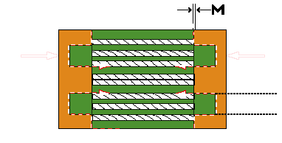
The inlet side of the gear pump
As mentioned previously, we can push the bearings (increasing the force, F) up against the gears to decrease leakage (decreasing the spacing, M). As F increases, M decreases, thus, the gears and bushing increase in friction and mechanical efficiency decreases. When you increase the pressure on the inlet side of the pump, leakage will increase around the gears. To reduce the leakage, you must push the bearings and gears closer (increasing F), causing an increase in friction. That is why inlet pressures over 1500 lb/sq in, are not used.

Principle of the Shear Shaft
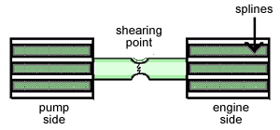
Gear pumps are built using a shear shaft principle. That is, if the pump fails, the shear shaft breaks and this allows each of the gears to rotate in its own part of the system (pump side or engine side) and nothing else will happen to the system. This phenomenon is similar to a fuse in an electrical system. When the electrical system overloads, the fuse breaks, causing the circuit to break without damaging the rest of the electrical circuit.
Principle of the Reciprocating Piston Pump
These kind of pumps attain volumetric efficiencies of up to 98% and they can maintain pressures from 1500 to 6000 psi. They can achieve overall efficiencies of up to 92% and can move fluid volumes up to 35 gallons per minute.
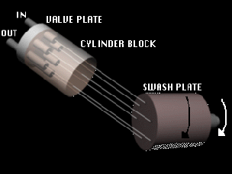
As the cylinder block rotates, space between the block and the pistons increase, letting in more oil. As the block rotates from bottom dead centre, the reverse occurs and the pistons push oil out through the outlet. When the pistons move down, the suction caused by the vacuum from the space, created by the movement of the piston, pulls in oil. Changing the angle between the swash plate and the cylinder block gives a longer pumping action and causes more fluid to be pulled in. As the cylinder block rotates, the piston cylinder openings over the inlet and the outlet vary. When cylinders 4-6 take in hydraulic fluid and act as the inlet to the pump, then cylinders 1-3 push the hydraulic fluid out and act as outlet to the pump.
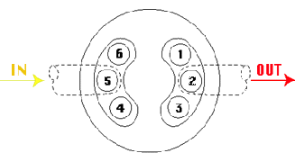
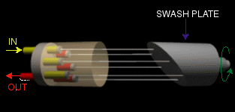
As the shaft and swash plate rotate, the piston will suck oil into the cylinder block and as the shaft and swash plate keep on rotating, the piston pushes oil out through the outlet. Pumps can be made to move more or less oil volume. The following formulae may be used to determine the volumetric output of a piston pump, the pump horsepower, the pump's volumetric efficiency and overall efficiency.
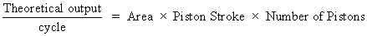
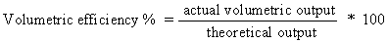
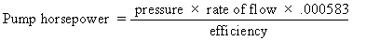
Here the number .000583 is a conversion factor from lb-ft/s to horsepower (HP)
hydraulic system check valves

Function of Check Valves
Check Valves are hydraulic devices which permit flow of fluid in one direction only.

Types of Check Valves
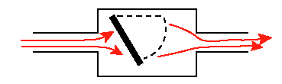
Flap type - this type of check valve is not used in hydraulics

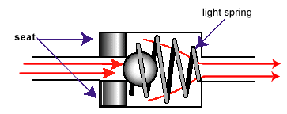
Ball Type – Too heavy and has too much inertia to move
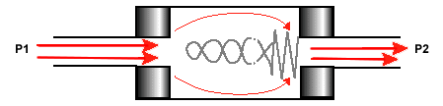
Poppet type valve is the preferred type that is used in hydraulics now. The front of the poppet (left side of the picture above) sits snugly on the hard seat (darker shaded areas on the left side). The poppet works on the following principle. When high pressure fluid (with pressure P₁ ) comes in on the left, it forces the poppet open. Since P₁>P₂ , the force on the left side of the poppet (F₁) is greater than the force due to the spring (F₂ ) and is just enough to open the poppet. But, when flow stops, or there is a high pressure flow from the right side of the poppet, then P₂>P₁ and the pressure forces the poppet against the valve seat, closing off the opening. Thus the fluid is allowed to flow through in one direction only.
Check valves are designed so as not to tolerate leakage. The purpose of the light spring is only to keep the poppet on the seat. The following Poppet type valve is used in submarines.
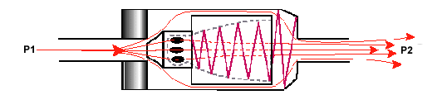
Most manufacturers use sharp-edged, very hard seats and soft, maybe plastic, poppets. Parallel seats are very good except that they are too prone to trapping contaminants between the seat and the poppet.
pressure control

(Pressure limiting device-relief valves)

Function
To limit the pressure of some section of the hydraulic system when the pressure has reached a predetermined level. That pressure level may be considered dangerous and, therefore, must be limited.

Principle of Operation
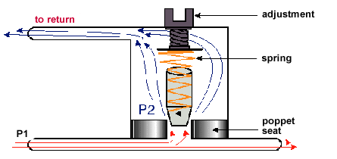
The adjustment screw at the top of the pressure relief valve is set for a certain pressure value, let us call it P₂. In general, even with a pressure of P₁, the poppet would lift up, except that the spring is strong and has downward force forcing the poppet closed. Poppet will not move until a pressure greater than that required is felt by the system (i.e., P₁>P₂). When the pressure increases, the poppet will move up, forcing the excess liquid to move through opening at high velocity. On other side of seat, pressure is zero because the back side of the relief valve is connected to the return line. When the pressure in the system decreases below maximum, poppet will return to its seated position, sealing the orifice and allowing the fluid to follow its normal path. These type of pressure relief valves are only made to be used intermittently.

Design Example
An example of designing the spring required for a poppet valve--
If the frontal area of the poppet is 1/3 square inches and the liquid pressure is at 6000 psi, find the spring force required to keep the poppet shut.
The frontal area is the effective area on which the fluid pressure acts. Even if the poppet sides are slanted, the pressure acts normal to that surface area, producing forces normal to that surface area. These forces can be resolved into force components perpendicular to the flow direction and force components parallel to the flow direction. The force components that are perpendicular to the flow direction for both the top slant face and bottom slant face cancel. The force components that are parallel to the flow direction for the top slant face and bottom slant face add.
This is equivalent to finding the area that the poppet seats and multiplying it by the pressure of the fluid, namely,

Circuits Using Pressuring Limiting Devices (PLDs)
The power system where the system relief valve is used to back up the regulator is an example of a use of the PLD. In such a system, the pressure setting, P₂, is set 125% above the system pressure. Rate of flow is dependent upon engine speed.
Thermal relief valves are set at 150% of system pressure. When the temperature (T) changes, the liquid expands more than the expansion of the hydraulic tubing. Since T increases, the pressure (P) increases. Thus, the tubing will burst unless there are thermal relief valves in the system. Set at one pressure, the thermal relief valves are connected to the return lines because the pressure there is close to nil. This only works when the selector valve is set in the neutral position.
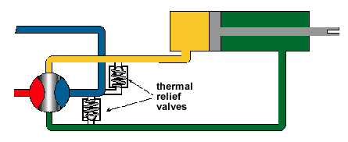
Force Limiting Device (FLD). Suppose that we want 1000 pounds of force to move a certain control surface. But our system can deliver 3000 pounds per square inch. If that pressure can be delivered on a 2 square inch piston head that moves the control surface, we would be= 6000 lb, a much higher force than is needed. We can put a force limiting relief valve (FLD) which would limit the force to 1000 lb by adjusting the FLD to act when the pressure reaches 500 psi (1000 lb/ 2 square inches). After the FLD is used, you need to put the selector valve at neutral so that no system pressure will be lost.
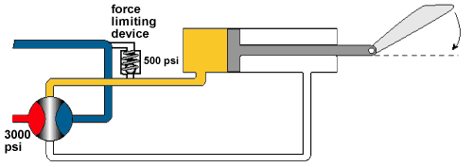
Force limiting circuits for gun chargers. When a gun is fired and a bad shell is put into the gun, the gun will stop working. Gun chargers do the work of removing the bad shell and then replacing it with a new shell, pulling the charging handle back, and the gun will be ready to fire again. The gun charger FLD is set so that a minimum force is used to pull the charging handle back.
Blow up devices. When a plane is coming in for landing on a carrier deck, the brakes are set and the selector valve is put at neutral. If the plane is waved off on its landing attempt, the brakes must retract quickly so that the plane does not stall. Therefore, when the pilot is waved off, he will push the throttle to get more speed to get away from carrier. In doing so, the air pressure force acting on the brakes, F, is so great that it moves the brake. In doing so, the piston moves to right, causing fluid to flow (in the red line) and to push on the relief valve. This action allows more oil into the other line (the white line) which in turn pushes on the piston and repeats the process. After the pilot reacts to this situation, he will change the selector valve position (if he has to change it), to move the brake back into its non-deployed position.
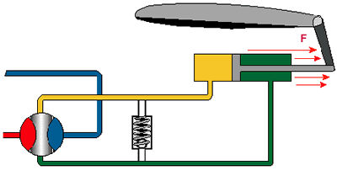
hydraulics system accumulators

Principle of Operation
At the bottom of the accumulator is a gas valve. Compressed gas at about one half the system pressure is let into the accumulator through the gas valve. This forces the diaphragm that separates the oil side from the gas side to "pop" up towards the oil side. Then oil is sent through the system. When the system pressure reaches a point when it is greater than the pressure of the accumulator, the diaphragm will deploy (inflate). Using Boyle’s Law, the compressed gas will increase in pressure as its volume decreases. The diaphragm will move up or down, depending on system pressure.
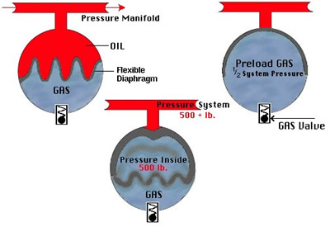
When the diaphragm is at half way, the gas volume will be ½ as much as it was initially, while the accumulator pressure will be twice as much as its pre-load pressure (i.e., 1/2 system pressure). Therefore when the accumulator is at half volume of gas, it will be charged at full system pressure.

Boyle’s Law
In a confined gas at constant temperature, the pressure is inversely proportional to its volume--that is, a gas with initial pressure P1 and volume V1 will have new pressure P2 and volume V2 such that P1V1 = P2V2. The product PV equals nRT, the product of n, the number of moles of the gas; R, the universal gas constant; and, T the temperature. Thus, for constant temperature, the product nRT is a constant.

Uses of an Accumulator
- Absorbs the shocks due to rapid pressure variations in a hydraulic system
- Helps maintain a constant pressure within the hydraulic system
- Helps the hydraulic pump under peak pressure loads
- It is an emergency source of power (the braking system has its own accumulator)

Servicing Procedure
The preload is checked every day. Nitrogen and helium are preferred to compressed air. Oxygen leaks into the oil will cause spontaneous combustion and that is why it is not used in the accumulator. Carbon dioxide (CO₂ ) is not used because it liquefies at 800 or 900 psi (which is considered low pressure compared to the pressure requirements of the system).

Accumulator Shapes
A. Spherical Type
The accumulator has to withstand about 450,000 lb of force. The spherical shape is used because a monocoque (single shell) body is the strongest and can withstand high pressures before failing.
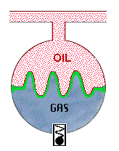
B. Bottle Type
This shape is not used because of bladder which expands and contracts
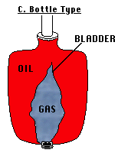
C. Cylindrical Type
This type is not used very often because friction will cause the wearing of both wall and piston, thereby allowing the gas pressure to escape. Oil and gas blowby (bypassing of piston by high pressure gas and oil) can occur.
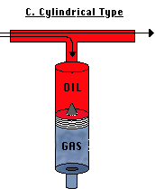
hydraulic system hand pumps

Functions
- Hydraulic system hand pumps are used to test the hydraulic system when the plane is on the ground; and,
- acts as an Emergency system of power

Principles of Operation
The hand pump converts the power of a human being to hydraulic horsepower. For this reason, such pumps are used in older model aircraft.

Types
There are several types of handpumps.
- Single action - single impulse (S.A.S.I.)
- Double action - double impulse (D.A.D.I.)
- Single action - double impulse (S.A.D.I.)

Analysis of a S.A.S.I. Pump
The pump works on the principle of mechanical advantage.
When pilot moves the handle away to L (see diagram below), a low pressure is caused to form in the chamber of the pump, Z. Since the reservoir liquid pressure is greater than the pressure in Z, liquid is forced around the check valve from the reservoir line. When the pump handle is moved to R, a positive pressure will form in Z, causing the check valve to the reservoir side to close. Since the hydraulic system liquid is incompressible, it is forced out through the bottom check valve to the system line.
Suppose the force delivered by the pilot was F₁ = 100 lb, at a distance D₁ = 20 inches from the pump handle pivot, and suppose that D₂ = 1 inch from the pivot to the pump piston. Then by moment equilibrium (F₁D₁=F₂D₂), the force acting on the piston would be F₂ = 2000 lb. If the piston area on which the oil acts is A = 2 square inches, then the pressure developed is 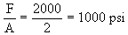
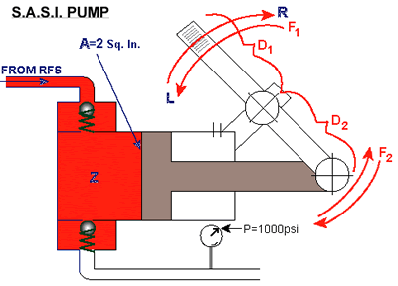
The volumetric output . In this case, . But a man’s average output is about 50 lb for F₁. Therefore, the piston area must be made half its present size (if the pressure is to remain constant). Thus, volumetric output will then decrease to 1 cu. in., since .
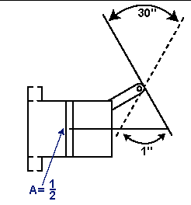
Problem: (SASI Pump)
Given a SASI pump connected to a hydraulic system under 3000 psi pressure and the mechanical advantage of the pump (the ratio of D₁ to D₂ ) to be 30 to 1, find:
1) the number of cycles needed to pump 300 cubic inches of fluid into the system; and,
2) the force to be applied at the pump handle. Assume that the piston surface area is 0.5 square inches.
Since the system pressure = 3000 psi and this acts on a surface area of 1/2 square inch, the force generated by the hydraulic fluid is 1500 lbs.
Using the mechanical advantage of 30 to 1, we find that the force at the pump handle will be
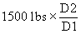or 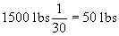.
Since the piston stroke is D₂, the volume moved per cycle is D₂ times the piston surface area
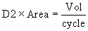
or
Thus, per cycle, 0.5 cubic inches of fluid is pumped into the system.
The number of cycles needed to pump 300 cubic inches of fluid may be found from
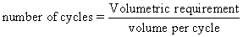
then
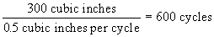

Analysis of a D.A.D.I. Pump
The DADI pump works in the same way that the SASI pump works, except that while chamber A is filling up from the reservoir, chamber B is pumping oil to the system.
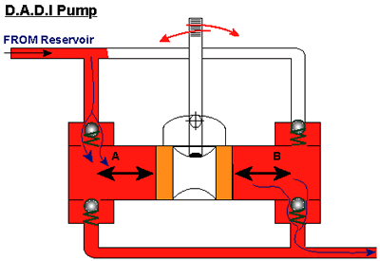

Analysis of a S.A.D.I. Pump
As the pump handle pulls the piston to the left, the oil trapped in A is pushed out through check valve 1 to the system. At the same time, a low pressure is created in B and ball 2 opens, letting in oil. As the pump handle pushes the piston to the right, a positive pressure is created in B which closes check valve 2. But, since oil in B is trapped, it escapes to side A when the pressure is great enough to open check valve 3. Now that the oil is in side A, the pressure on that side is still great enough to open check valve 1.
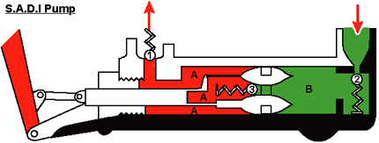
flow control

Selector Valves
Selector valves are used as (1) directional control devices to insure the movement of the hydraulic fluid flow in the proper direction, and (2) as stop-locks to lock the selector switch in a certain position.

Types
There are three types of selector valves. They are rotary type, piston type and poppet type.
Rotary types
Rotary type selector valves are plugs within which are passage ways for the fluid to move through. Tubing from the hydraulic pump or return line are connected to the rest of the hydraulic system by movement of the plug. You cannot use high pressure oil because of leakage around the plug. To reduce leakage, you might want to make the plug fit more tightly into the selector valve body. However, the better you make the fit, the more friction will exist between the plug and the selector valve body, making it difficult to operate.
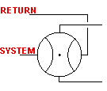 | 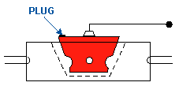
Piston Type
Positions 1, 2 and 3 (shown below) are representative positions for the piston-type selector valve. Position (1) is the position of the selector valve, for example, upon the extension of the landing gear or the lowering of flaps. Position (2) is the position of the selector valve upon retraction of the landing gear or the raising of the flaps. Position (3) is the stop-locking position of this type of valve. This piston type valve uses the Vickers spool mechanism in which the piston "lands" isolate the high pressure oil (red area) from the low pressure oil (blue area).
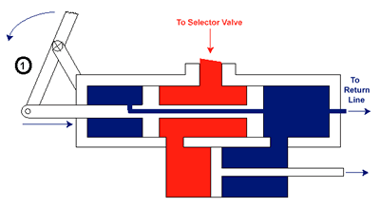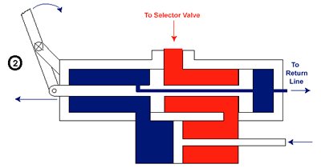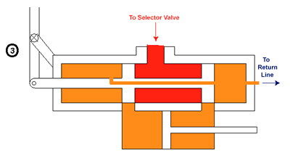

Poppet Type - Stacked Poppet
In this type valve, any movement of the handle (at the lower right of the diagram) changes the camshaft and cam settings, thereby opening and closing the poppet valves and letting high and low pressure oil to the proper sides of the actuating cylinder and return line, respectively.
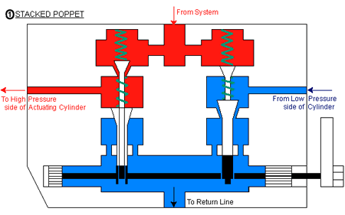
In in-line poppets, the poppet valves are set up along a cam shaft, in the same manner as for the intake and exhaust valves of a car engine. The camshaft is represented by the "sinusoidal" line in the diagram below. However, the motion of the poppets are controlled by the pilot.
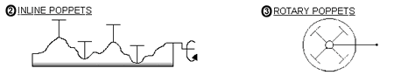
These mechanical type selector valves require a fair amount of tubing. In order to reduce the amount of tubing, electric switches have been used to operate solenoids which operate the selector valves. This has the added advantage of reducing the wasteful motions of pilot. This is type of combined electronic circuits and hydraulic system is called electrohydraulics.
flow conditions
Flow conditions can be of several types. Flows may be steady (meaning not time varying) or unsteady (meaning that the flow is time varying). An example of unsteady flow is when actuation starts or stops, the flow becomes dependent upon the motion of the actuating piston. A steady flow example is when the piston has reached its operating speed in a very long pipe, the flow in the pipe will no longer vary as a function of time.

Flows may be one-dimensional where the flow parameters (for example: density, velocity, temperature, pressure) vary as a function of one spatial variable (for example, x) and variations in the other two spatial dimensions (i.e., y and z) are negligible by comparison. Flows may be two-dimensional where the flow parameters vary as functions of x and y, for example, while variations in z are small and can be neglected. Flows may be three dimensional where the flow parameters depend upon all three spatial dimensions. Flows may be incompressible, i.e., the flow density does not change with position or time. Flows may be compressible, such as in the case of a gas at high speeds. Flows may be described as creep, laminar or turbulent. Creep flow occurs in highly viscous fluids at very low speeds (fluids that exhibit a high resistance to motion; for example, molasses). For flow speeds that are higher than in creep flow, whether the flow is laminar or turbulent depends upon the Reynolds number. Flows that start as laminar flows may transition to turbulent flows, (for example flows around spheres or over wings).

Laminar Flow
Laminar flows occur when fluid particles move along straight, parallel layers. These layers are called laminae, from which laminar flow gets its name. Laminar flows normally occur during steady state conditions. The velocity of each layer may be the same or may change slightly from layer to layer. The fluid particles of each layer do not mix with the fluid particles of other layers. In steady situations, the energy of the fluid is conserved.

Turbulent Flow
Turbulent flow occurs when the particles of fluid move in all directions and fluid mixing occurs. This may occur when the flow becomes unsteady. Turbulent flows can also occur during steady conditions when there are small velocity and pressure variations compared to the mean (or average) flow velocity and pressure, BUT the mean flow velocity and pressure DO NOT vary with time. Mean flow velocity and pressure represent the average velocity and pressure of all the fluid particles in the flow. In unsteady situations, the energy of the fluid is not conserved. Turbulent flow will cause a pressure drop. Because the fluid particles motion defines the flow, this type of flow is sometimes called particle flow.

Causes for Transition
Flows may transition from laminar to turbulent due to the following reasons:
- Roughness of the inner surface of the pipe
- Abrupt changes in pipe directions – e.g., 90 degree bends
- Pipe size changes – a velocity increase in the fluid due to a cross-sectional area decrease in the pipe can cause the flow to change from laminar to turbulent
The type of flow (whether laminar or turbulent) depends upon the Reynolds number, R_{N}, where
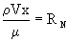
Here, the Greek letter, rho, represents the density; V is the velocity of the flow; x is the pipe hydraulic diameter (equal to the diameter for a circular pipe); and, the denominator, given by the Greek symbol, mu, represents the fluid viscosity.
flow restrictors

Introduction
Since the speed of the actuating cylinder is determined by the rate of flow of the hydraulic fluid, we may need a device to control the rate of flow. This device is called a flow restrictor. Since none of the selector valves meter the flow, we must use the restrictor.
There are four types of restrictors:
- one way fixed restrictor
- one way variable restrictor
- two way fixed restrictor
- two way variable restrictor

The One Way Fixed Restrictor
The One Way Fixed Restrictor is not used all the time, but, it is being used more than the other types of restrictors. It is a check valve type restrictor with a drilled hole through the seat to the other side of the check valve. When the flow pressure seats the check valve ball (i.e., flow moving from right to left), some of the fluid can still reach the other side through the drilled hole in the seat. However, since the hole size is fixed, the amount of fluid passing through the passage to the other side is also fixed.
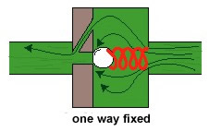

The Two Way Fixed Restrictor
The Two Way Fixed Restrictor is not used because it restricts the flow on the side of the restrictor where we want the flow to occur normally. Because the passage size is fixed, the amount of fluid moving from right to left, or vice versa, is fixed, as well.
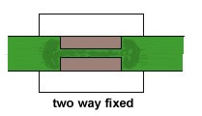

The One Way Adjustable Restrictor
The One Way Adjustable Restrictor is being used nowadays. It is the same as the One Way Fixed Restrictor but the amount of fluid passed through the drilled opening in the seat is regulated by means of an adjustment screw.
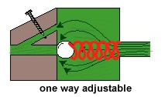

The Two Way Adjustable Restrictor
The Two Way Adjustable Restrictor is the same as the Two Way Fixed Restrictor, but it also has an adjustable screw that can be used to further restrict the amount of hydraulic fluid passing through the opening.
synchronising circuits

Introduction
During aircraft turns or manoeuvres, if wing air loads on one wing are greater than loads on the other wing, and, we attempt to sweep the wings back or sweep them forward, these motions will occur so unevenly that probable loss of aircraft and pilot will result. Therefore, if we want to synchronize our sweepback motion, we must use devices called flow equalizers.
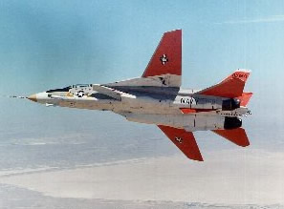
Another example where flow equalizers are needed is in case of air-to-air missile attack. Suppose our selector valve is set to neutral and we try to get away from a rocket missile by turning right or left. The pressure forces on the wings would be so unequal that the wing actuating cylinder (of the wing undergoing the smaller turn radius) would act as a pump, since its greater pressure loading would cause wing sweepback. The hydraulic fluid would be pushed out of one cylinder and the only path that it could take would be to the other wing's actuating cylinder, causing that cylinder’s wing to go in the opposite direction to that of the first wing. This would be catastrophic.
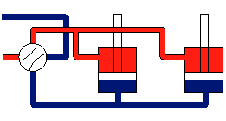
If a downward force is applied to the left piston and the selector valve is closed, the oil is forced into the right cylinder causing the right piston to move up--a motion opposite to what is needed.

Flow Equalizer
A device that may be used as a flow equalizer is a power pump that is run in reverse. If the power pump direction were reversed, the flow would push on the outer teeth of the gear and not on the meshing teeth at the centre because the oil can’t be compressed. Since fluid moves towards the meshed teeth at the centre of the pump (A1), as well towards teeth closest to pump casing (A2), and since the fluid pressure acts on twice the teeth area (A2) than at A1, the gear direction reverses, as compared to the direction of operation of a power pump.
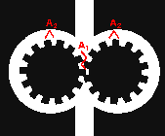
Thus the flow equalizer is made up of two power pumps placed side by side in which the drive gears of both pumps are connected (see the side view for the figure below). The main figure (the one in red) shows the two power pumps of the side view, cut along the side view's centreline and opened like a book. When one drive gear turns (2), it causes the other to turn as well (1) through the connection (the blue shaft). Since the volumetric output per revolution is the same for both sides, we have found the right device to keep synchronization.
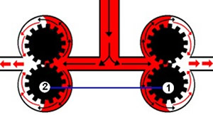 | 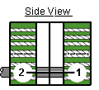
This kind of power pump is set between the two cylinders requiring equalization and would channel the flow to both cylinders (as shown below left). The VICKERS EQUALIZER setup is shown below right, where the VICKERS pumps are connected by a shaft at the centre of the diagram. Input is at the top of the pumps and outputs are shown by the red arrows.
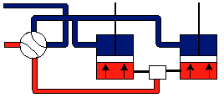 | 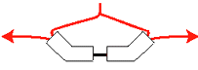

You should never connect the actuation cylinders of the two wings is series, since this type of circuit, for it to work, would require cylinder (1) to put out twice the fluid pressure, or even more, in order to operate itself and cylinder (2) [see the figure below). The hydraulic fluid in this series type of circuit will burst the hydraulic tubing, due to the fluid pressures required to operate both actuating cylinders, and, because this type of circuit does not compensate for expansion or contraction of the hydraulic fluid. The tubing between cylinders and to the selector valve are coloured both blue and red because they can transmit high pressure hydraulic fluid as well as return line pressure hydraulic fluid.
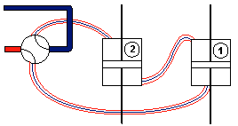

Sequencing Circuits
These circuits are used to cause certain operations to occur in a particular sequence. Sequencing circuits have been used, for example, for the complete ejection of a pilot from the plane. The sequencing valve is such that it sends hydraulic fluid through the valve to the other sequencing valves and actuating cylinders. As the piston rod (of the extreme left cylinder) moves upward, it activates the sequencing valve releasing hydraulic fluid to the next cylinder.
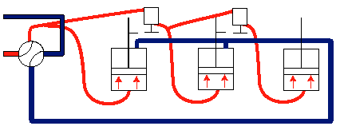

Sequencing Valve Operation
As the actuating cylinder piston moves upward, it hits the rod of the sequencing valve (shown in green). The rod, in turn, moves up into the sequencing valve pushing the poppet up and releases the hydraulic fluid from the holding side (blue side) to the releasing side (red side), permitting it to go to the next cylinder and sequencing valve.
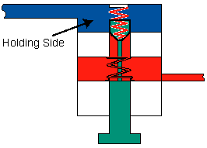
In the diagram below, the system is set so that the sequence of actuation is 2,4,3,1.
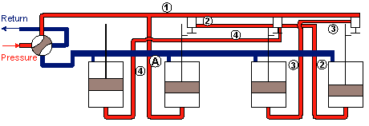

Double Sequence
We can design a system so that it can perform a double sequence of actuations. In the diagram below, the system is set so that when the selector valve is open to the "red" side, the sequence of events from left to right is 1,3,4,2 (cylinder numbers in red). When the selector valve is open to the "blue" side, the sequence of events goes from right to left and is 4,3,1,2.
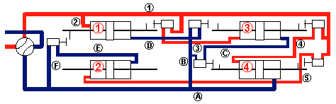
By proper connection of the sequencing valves and actuating cylinders, any sequence of events can be made to occur.
types of hydraulic actuation cylinders

Introduction
The function of the actuating cylinder is to take the pressure and hydraulic fluid flow and change them into either linear or rotary motion. The ones that have been employed more commonly are the double action actuating cylinders, because they work in both directions.

Group I

A. Single Piston, Single Rod
This type of actuating cylinder has one piston connected to one rod. Such a device requires the piston rod to move into the actuating cylinder to cause one motion to occur and to move out of the cylinder to cause the reverse motion to occur.
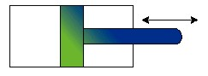

B. Single Piston, Double Rod
This is an equal displacement cylinder and could be used on an aileron system or an automatic guidance system (as shown in the second diagram below).
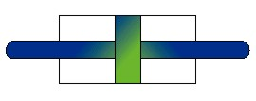
The piston ends can be attached to a pulley system that can pivot a control surface. The motion of the piston to the right, due to high pressure fluid in the left side of the actuating cylinder, can be activate the pulley system and pivot the control surface upward. By reversing the flow, the opposite motion will occur.
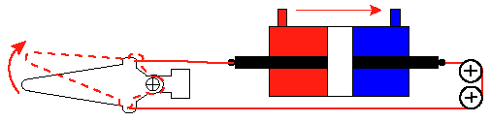

C. Double Piston, Double Rod
This type of actuating cylinder would be used on bomb bay doors (figure shown below right). High pressure fluid enters the centre section of the cylinder, acting on the two pistons simultaneously. The rods would be extended outward, causing the doors to rotate open. When the high pressure fluid enters the two end sections (shown in blue), this operation is reversed, closing the bomb bay doors.
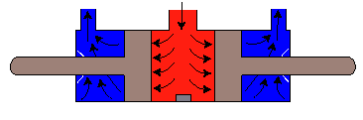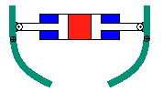
Another application for the Double Piston, Double Rod cylinder is the brake system of a vehicle.

Group II

A. Single Action Cylinders
Bungee Type- this type of actuating cylinder is used where gravity or weight can act as high pressure oil. Either a rubber mass or a spring loading device counteracts the weight. Its disadvantages include:
- The decrease in piston stroke on account of weight and size of spring or inserted rubber mass;
- The fact that oil on the spring side of the piston must move both the piston and the spring;
- The size and weight of the spring to do the job might be too great.
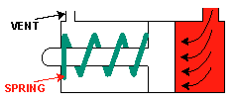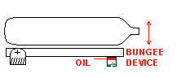

B. Dashpot Cylinder
A dashpot cylinder is any cylinder which decelerates piston movement at the end of the stroke. The piston has a small attachment at the piston head side that fits into a dashpot (A). When the piston moves to the left in the diagram below, by forcing the fluid out of the dashpot (A), energy is taken out of the system, causing the piston to slow down.
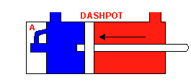

C. Locking Cylinder
The locking cylinder is a cylinder which has a locking device attached to it. This cylinder is a "fail-safe" design so that it will not actuate beyond some given point.
- The locking cylinder is part of the Fail-safe design philosophy: if the cylinder is malfunctioning, it should fail in a position that is safe for the rest of the flight.
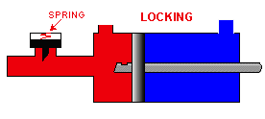

D. Telescoping Cylinder
The telescoping cylinder is a cylinder-piston configuration within a cylinder-piston configuration which is used to get a larger stroke from a small cylinder. This may be required when the cylinder must fit into a small space but the piston rod must move through a large distance.
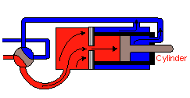

Group III

A. Stationary Piston-Moveable Cylinder
Whenever we don’t want the piston rod to extend into an environment that can damage the rod or contaminate the hydraulic fluid (for example, a stream of sea spray or in the path of little pebbles when landing or taking off from a rough airstrip), we make the piston cylinder extend instead of the piston rod. The type of cylinder we use is the stationary piston moveable cylinder.
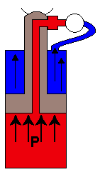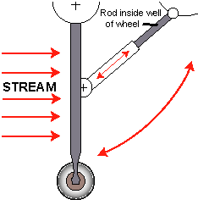

B. Rotary Motion Actuating Cylinder
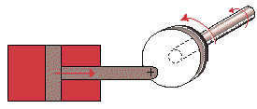
In this type of cylinder, as the piston moves backwards and forwards, it rotates the rotating cam (circular cam in the centre of the diagram). The cam is connected to a shaft which rotates as well, thus converting the linear motion of the piston into the rotary motion of the cam and the shaft.
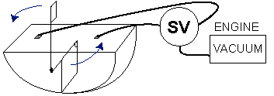
Vacuum rotary windshield wiper
An example of the rotary motion actuating cylinder can be found in certain windshield wiper systems (above). In these windshield wipers systems, as the wiper makes the last part of its stroke, it is designed to trip a selector valve (SV) connection, reversing the air-vacuum flow so that the wiper will reverse direction.
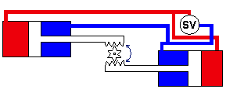
In the double cylinder system shown above, both pistons move in tandem to rotate the gear shown in the centre of the diagram. That gear may be connected to a shaft that rotates. Thus, we have converted the linear motion of the piston rods into a rotary motion of the gear.
hydraulic motors & variable displacement pumps

Hydraulic Motor
A hydraulic motor is a device that generates rotary motion directly from the hydraulic system. An example of this is a 4-wheel drive system.
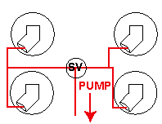
To change the hydraulic pump into a hydraulic motor, several changes need to be made. One of these changes is putting a gear box on the shear shaft.
Hydraulic motors give a steady, continuous torque. They are small and compact.

Vickers Hydraulic Pump
When the hydraulic pump is connected to a selector valve, the hydraulic oil coming into the pump pushes down on the pistons, causing the whole piston assembly to rotate. If this assembly is connected to a shaft, the shaft will rotate with great rotational speed.
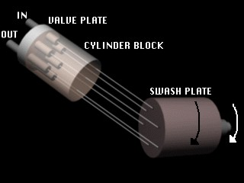
The Vickers Hydraulic Motor has a gear reduction box which is attached to the pump to reduce the rotational speed to a useable range. When a system's energy is conserved, input torque x input rotational speed = output torque x output rotational speed. If there are no energy losses in the pump and we decrease the rotational speed, we increase the torque generated.
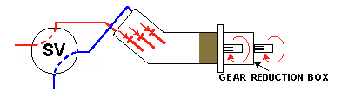
This type of motor is used in gun turrets to get azimuth directional control. The speed of movement of the turret depends on the rate of hydraulic fluid flow, which can be controlled by restrictors (see section 1.16 - Flow Restrictors).
It is also used in operating a radar, since it does not introduce electronic interference due to the movement of radar.
The hydraulic pump may be used for starting engines, but it is difficult.
Also, it may be used in wing sweep (a large gear moved by smaller gears attached to the motor shaft).
It is used in winching systems; for example, to haul up cargo, personnel, casualty baskets and the like, on helicopters (US Coast Guard rescue helicopters, US Navy Sea Stallions, US Marines, and US Army Hueys and Chinooks)
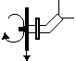
The rotation of the motor lowers the winch
It may be used to spin up the aircraft's wheels before landing, to get the wheel speed up to the touchdown speed of the aircraft. This technique may be used to increase the life of the aircraft's tires.
The motor can be used with variable displacement pumps for automatic transmissions and could be operated by a metering selector valve for movement of gun turrets.

Variable Displacement Pumps
Variable displacement pumps work by having the pump side at an angle to the horizontal. The movement of the pistons within the pump will draw hydraulic fluid into (or expel fluid out of) the pump. The amount of fluid drawn into (or expelled out of) the pump will depend upon the angle the pump makes with the horizontal. The pump could be controlled by a yoke that moves the pump to different angles, thus varying the pump displacement.
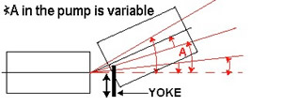
automatic hydraulic transmissions
Examples of where automatic hydraulic transmission may be employed will be discussed.
Let us say we want to operate the radar on a jet aircraft. Suppose the radar itself is being operated by an alternator and the alternator frequency (number of cycles per second) depends on the RPM of the engine running the alternator. The RPM of the engine may change due to operational requirements, while we want a steady number of cycles coming out of the alternator to run the radar.
Let us take a hypothetical case of a turbojet aircraft. At take-off, the jet is "revving" at 12,000 RPM, at cruising altitude the jet runs at 6,000 RPM and when landing the jet runs at 3,000 RPM. Let’s say we want the alternator to work constantly at 6,000 cycles. This is what we do.
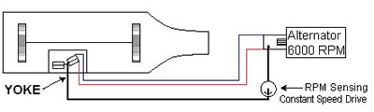
As the speed of the turbine increases because of take-off, the alternator cycles also increase. Sensing the increase, the constant speed drive "tells" the yoke on the variable displacement pump of the automatic hydraulic transmission to decrease the pump angle, thereby decreasing the volumetric output of the pump. This, in turn, will decrease the speed of the hydraulic motor that runs the alternator, therefore, decreasing the cycle speed of the alternator.
As the turbine decreases its rotational speed when the aircraft reaches its cruising altitude, the constant speed drive senses the decrease and it "tells" the yoke on the variable displacement pump to increase the pump angle to offset the decrease in speed of the jet engine. The increased pump angle will increase the volumetric displacement of the pump as well as the speed of the hydraulic motor that runs the alternator, thereby increasing the cycle speed of the alternator.
At landing, the engine speed decreases further so that the aircraft can lose lift and land. Again, the constant speed drive, sensing the decrease in engine speed, "tells" the yoke on the variable displacement pump to increase angle to offset the decrease in engine speed. The increase in pump angle increases volumetric displacement, causing an increase in speed of the hydraulic motor that runs the alternator and, in turn, causes the cycle speed of the alternator to increase.
The constant speed sensing device could be connected to a pump stroke control. The pump stroke control replaces the yoke as the means of increasing or decreasing the angle of the variable displacement pump.
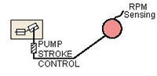
The hydraulic motor and variable displacement pump can be used separately, as is shown on the diagram below. The pump can be connected to the engine and the motor to the alternator. As one pump decreases its angle, the motor is made to increases its angle, increasing the torque generated to the alternator. As one pump increases its angle, the motor is made to decrease its angle, decreasing the torque and increasing the RPM to the alternator.
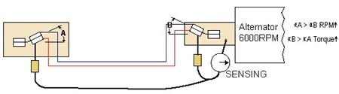
With this set-up, we can get any variation of torque and speed (RPM).
variable displacement pump power system & open centre type power systems
The pump shown in the diagram was used in the late 60s and 70s. It may still be used in aircraft of that era. The pump works in this manner: The accumulator always keeps a pressure in the self-contained reservoir. Let’s say that the hydraulic system has finished actuation. As the pressure builds up, the pressure felt in the area around the selector valve is felt at the regulator piston. As the pressure builds up, the fluid pressure on the regulator piston will be higher than the spring force, causing the piston to move downward. As the piston moves down, the yoke will pull the piston chamber in the pump down, decreasing the pump angle and causing a decrease in the volumetric output of pump. As the actuation starts again, the pressure decreases, making the piston move upward (fluid pressure force being less than the spring force) and moves the yoke upward, increasing the pump angle and the volumetric output. The relief valve to the left of the regulator acts in same fashion as that of old systems (it opens a path to the accumulator if the pressure in the system is higher than the allowable range of operating pressures in the hydraulic system).
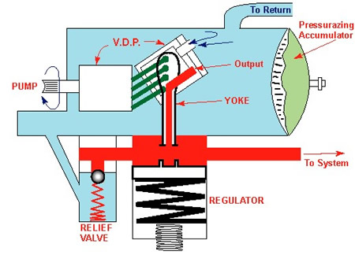

Open Centre Type Power System
Such a system has not been used in aircraft since 1945. However, since that time, it has been used in power steering systems of cars.
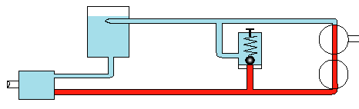
This type of system was used in simple aircraft. The selector valve used in this kind of system was an open centre selector valve which allowed fluid to pass through the selector valve continuously, but directed fluid flow to other flow routes by movement of the selector valve. The route the fluid took depended upon the pilot and the task to be accomplished (for example: moving flaps, or ailerons). When the task was complete, the pushing action of the hydraulic fluid on the piston in the selector valve would cause the pressure to build in the system. Therefore, it was necessary to put the selector valve in "neutral" when the task was complete. When the selector valve is placed in neutral, the fluid pressure is the same as the return line pressure.
Caution: Use 1 open centre selector valve at a time, always returning it to neutral. Never use 2 selector valves simultaneously as you can damage the hydraulic system.
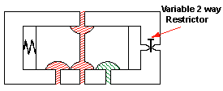
To automate the selector valve's return to the neutral position, you can use either a pressure control sensor or a time delay (spring and adjustable restrictor) whereby the pressure on the piston will move the piston back to the centre.
pressure boosters, pressure de-boosters, & hydraulic fluids

Pressure Boosters
Pressure boosters are rarely used in aircraft (almost all planes use de-boosters). If we need higher pressure, we must change the ENTIRE power and actuating system. This adds weight that is not needed. In general, we cannot put in larger pistons and piston cylinders to increase the power, because, normally, we don’t have the room for it. A simple solution is to raise the pressure in a LOCALIZED area.
The function of a pressure booster is to act like a transformer--that is, it raises the pressure of a small circuit connected to the power system. The booster is a cylinder made up of two pistons of different surface areas that are connected. The larger surface area (A1) is connected to the inlet side of the hydraulic system, and, the smaller surface area (A2) is connected to the outlet side of the hydraulic system
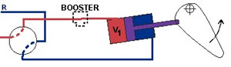
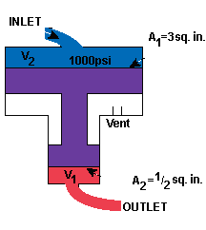
Example:
Suppose that the actuating cylinder (used to move the control surface) normally gets hydraulic fluid at a pressure of
p = 1000 psi and that this pressure would act on a piston surface area A = 10 square inches. The total force developed F would be p times A or 10,000 lb. But, suppose we need a force of 60,000 lb to move the control surface... So we add a booster.
If the inlet side area A1 is 3 square inches, then the force, F, developed by the hydraulic fluid is
Since the pistons of the booster are connected, and we assume that they have negligible inertia, then the force developed on the smaller piston is the same as the force on the larger piston. If the outlet side area A2 is 1/2 square inch, then the pressure developed on the outlet side would be
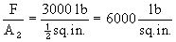
At the actuating cylinder the force developed would be the pressure times the area of the actuating cylinder or
(6000 lb/sq. in.) x (10 sq. in.) = 60,000 lb
as required.
Disadvantages of a Pressure Booster
It requires a very large booster stroke to meet the requirement
If a 3 inch piston stroke is needed from the actuating cylinder moving the control surface, then the total volume of fluid moved by the actuating piston's movement is stroke x piston area = (3 inches) x (10 square inches) = 30 cubic inches
This is the volume of fluid that must move out of the booster to the actuating cylinder. Thus the smaller piston in the booster must stroke a distance equal to the volume of fluid needed divided by the piston area = (30 cu. in.) / (1/2 sq. in.) = 60 inches = 5 feet!
Pressure Boosters must be built into the aircraft during the aircraft's construction, if high pressure is needed in the hydraulic system.
Weight of the pressure booster is high if it is put into the aircraft, thereby reducing payload aircraft can carry.
Leakage from the pressure booster is an important factor and will increase possibility of fire hazards.

Pressure De-Boosters
Pressure deboosters are used to reduce the pressure in the system to a level that can be used by certain devices. Pressure de-boosters are pressure boosters turned upside down (that is, the inlet side of the booster has the smaller area piston and the outlet side has the larger area piston). They are employed in power brake systems, using engine power to help apply the brakes. Since aircraft wheels are made of magnesium, any high pressure on the wheels will cause them to split. That is why they must de-boost the pressure gotten from engine.
The inlet line to the debooster comes from the power brake control valve. The outlet line goes to the brake system. This valve meters hydraulic fluid and hydraulic pressure directly. The force applied to the wheels to make them stop is proportional to how hard you push on the rudder pedal. It is normally used for a 1 or 2 cubic inch application.
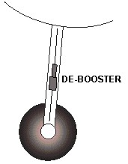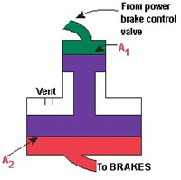

Hydraulic Fluids
Hydraulic fluids that have been used are of several types: water-based, mineral-based and synthetic type oils. Each has its advantages and disadvantages. Though several types are listed here, newer types of oils are being developed.
- Water-based MIL-O-7083 type hydraulic fluid has been used in naval aircraft because it is not flammable. However, it is still corrosive. It is a water based lubricant which is chemically treated. Its commercial name is HYDROLUBE
- Mineral-based petroleum oil MIL-O-5606 has been used by NATO. Old name of this type fluid is AN-VV-O-366. It has a cherry red dye added to it.
One caveat needs to be stated here: You are not allowed to mix oil bases since the usefulness and range of use of the oil may be degraded.
- Synthetic Oils have much appeal. They are non-flammable and work over a wide temperature range. One such synthetic oil is known as Skydroll 500 and it has a purple or green colour. It is made from a phosphate-ester base.
Caution: Never use a vegetable-base oil. At high temperatures, vegetable-based oils form a residue which is gummy and can clog the hydraulic system, which can lead to catastrophic results.

