principles of navigation

history
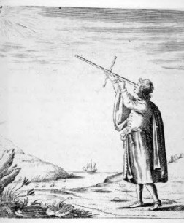
Early pilots looked out of their open cockpits for roads, rail lines, and airports to find their way in daytime flight. Pilots watched the horizon to make sure they were flying with the aircraft's nose and wings in the proper position relative to the ground, called attitude. As airmail pilots began flying at night and in all kinds of weather in the early 1920s, new equipment helped pilots navigate and maintain aircraft attitude when they could not see the ground. Navigation aids were developed for use inside the aircraft and also to guide the pilots from the ground.
Simple equipment to help pilots maintain attitude was introduced during the 1920s. These devices included such ideas as a bubble of liquid to help keep wings level and a device that measured pressure at different heights, called an altimeter, that told a pilot his altitude above ground level. A simple magnetic compass for direction was installed either in the cockpit panel or held in the pilot's hand.
In 1929, Lawrence Sperry and his Gyroscope Company introduced important new technology—the Artificial Horizon—that operated on gyroscopic principles. With its sensitive attachments, Sperry's device could detect forces that upset the gyroscope's stable spin, then would activate the aircraft controls to maintain proper attitude while flying when visible flight was not possible.
In the 1930s, new mechanical aids emerged, some based on Sperry's gyroscope and others based on the rush of air through intakes under the wing or the aircraft belly to measure speed and altitude. Equipment outside the aircraft measured the velocity of the air as it entered one intake and exited another. The results were fed to the pilot to help him determine the aircraft's attitude and position.
Navigation information was displayed on a group of instruments called the basic or primary six, which included the attitude indicator, a vertical speed indicator showing the rate of climb and descent, airspeed indicator, turn-and-bank coordinator, a heading indicator showing the magnetic compass course, and the altimeter. These instruments are still used.
Refined versions of Sperry's invention appear in 2001 as the Inertial Navigation System (INS) and the Inertial Guidance System (IGS). These systems measure changes in the aircraft's location and attitude that have taken place since the aircraft left the ground. These new devices include an accelerometer to detect changes in airspeed as well as attitude. By determining the precise latitude and longitude before flight, then tracking every change in location, the INS or IGS tells the pilot where he has flown.
Radio navigation aids were developed around the same time as mechanical aids. In 1926, successful two-way radio air-to-ground communication began, and the first transmitter/receiver went into mass production in 1928. Teletype machines were installed so that all stations along an air route could transmit weather conditions to the pilot. Eventually the pilot used these stations to indicate the plane's location.
The earliest radio navigation aid was the four-course radio range, which began in 1929. Four towers set in a square transmitted the letters A and N in Morse code. A pilot flying along one of the four beams toward the square would hear only an A or N in the dashes and dots of the code. The dashes and dots grew louder or more faint as he flew, depending if he was flying toward or away from one of the corners. Turning right or left, he would soon hear a different letter being transmitted, telling him which quadrant he had entered.
The beams flared out, so that at certain points they overlapped. Where the A or N signals meshed, the Morse code dashes and dots sounded a steady hum, painting an audio roadway for the pilot. At least 90 such stations were in place by 1933, about 200 miles (322 kilometres) apart along the 18,000-mile (28,968-kilometer) system of lighted towers and rotating beacons. Unfortunately, mountains, mineral deposits, railroad tracks, and even the atmospheric disturbance of the setting sun could distort the signals.
The first radio-equipped airport control tower was built in Cleveland, Ohio, in 1930, with a range of 15 miles (24 kilometres). By 1935, about 20 more towers had been erected. Based on pilot radio reports, a controller would follow each plane with written notes on a position map. The controller would clear an aircraft for takeoff or landing, but the pilot still could decide on the best path for himself.
Until World War II, radio navigation relied on low frequencies similar to those of an AM radio. Devices such as the automatic direction finder and the non-directional beacon, like the 1920s system before them, used Morse code, and the detection of weaker to stronger volume let a pilot know if he was on course. After the war, higher frequency transmitters, called the very high frequency omni-directional radio range or VOR, further refined the early concept of allowing pilots to fly inbound or outbound along a certain quadrant on a line called a radial. These transmitter locations, their frequencies and identifying Morse codes are all printed on navigation charts. The various radio-based systems are sufficient for navigating between airports but are called non-precision aids because they are not accurate enough and do not provide enough information to allow a pilot to land.
Before World War II, the Civil Aeronautics Administration relied on pilots to radio their position relative to known navigation landmarks to keep the aircraft safely separated. During the war, radio detection and ranging (RADAR) was tested. Radar's primary intent was, and still is, to keep airplanes separated, not to guide them to a specific point.
In 1956, a TWA Lockheed Super Constellation with 64 passengers and six crew and a United Airlines DC-7 with 53 passengers and five crew collided over the Grand Canyon, killing all 128 people. The incident led to new federal funding for rapid development of radar, air traffic control procedures, and technologies for more precise navigation. The crash also led to an aviation agency reorganization that included creation of the Federal Aviation Agency.
Today's aircraft are tracked as computer-generated icons wandering across radar display screens, with their positions, altitude, and airspeed updated every few seconds. Pilots and controllers communicate using both voice and data transmitting radios, with controllers relying on radar tracking to keep aircraft on course. Today, cockpit navigation information is increasingly displayed on a monitor, but the position of information and its format are nearly identical to the basic six instruments of early and simpler aircraft.
New technologies, though, have led to a debate as to whether the federal government, using fixed electronic stations, or the pilots should control navigation like in the earliest days. The global positioning system (GPS) is one technology that allows pilots to accurately determine their position anywhere on the Earth within seconds, raising the question whether they need any help from the ground.
GPS is becoming the primary means of navigation worldwide. The system is based on satellites in a continuous grid surrounding the Earth, each equipped with an atomic clock set to Greenwich, England, called ZULU time. The GPS units in the aircraft, or even in a pilot's hand, find the nearest two satellite signals in a process called acquisition. The time it takes for the signals to travel creates a precise triangle between the two satellites and the aircraft, telling the pilot his latitude and longitude to within one meter or a little more than one yard. In coming years, this system will be made even more precise using a GPS ground unit at runway ends.
Despite these advances, pilots can still crash because they get lost or lose track of hazards at night or in bad weather. On December 29, 1970, the Occupational Safety and Health Act came into effect. It requires most civilian aircraft to carry an emergency locater transmitter (ELT). The ELT becomes active when a pilot tunes to an emergency radio frequency or activates automatically when the aircraft exceeds a certain force in landing, called the g-force, during a crash. This form of navigation aid, which transmits signals to satellites overhead, saves lives of injured pilots and crew who are unable to call for help themselves.
introduction
Navigation is the art and science of getting from point "A" to point "B" in the least possible time without losing your way. In the early days of aviation, navigation was mostly an art. The simplest instruments of flight had not been invented, so pilots flew "by the seat of their pants". Today, navigation is a science with sophisticated equipment being standard on most aircraft.
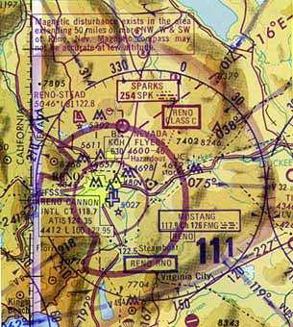
The type of navigation used by pilots depends on many factors. The navigation method used depends on where the pilot is going, how long the flight will take, when the flight is to take off, the type of aircraft being flown, the on-board navigation equipment, the ratings and currency of the pilot and especially the expected weather.
To navigate a pilot needs to know the following:
- Starting point (point of departure)
- Ending point (final destination)
- Direction of travel
- Distance to travel
- Aircraft speed
- Aircraft fuel capacity
- Aircraft weight & balance information
With this information flight planning can commence and the proper method of navigation can be put to use.
Basic Navigation
Pilotage
For a non-instrument rated, private pilot planning to fly VFR (Visual Flight Rules) in a small, single engine airplane around the local area on a clear day, the navigation is simple. The navigation process for such a local trip would be pilotage. (Bear in mind, however that the flight planning and preflight for such a trip should be as thorough as if the pilot is preparing to fly cross-country.)
The pilotage method of navigation developed naturally through time as aircraft evolved with the ability to travel increasingly longer distances. Flying at low altitudes, pilots used rivers, railroad tracks and other visual references to guide them from place to place. This method called pilotage is still in use today. Pilotage is mainly used by pilots of small, low speed aircraft who compare symbols on aeronautical charts with surface features on the ground in order to navigate. This method has some obvious disadvantages. Poor visibility caused by inclement weather can prevent a pilot from seeing the needed landmarks and cause the pilot to become disoriented and navigate off course. A lack of landmarks when flying over the more remote areas can also cause a pilot to get lost.
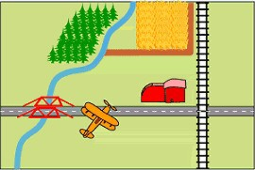
Using pilotage for navigation can be as easy as following an interstate highway. It would be difficult to get lost flying VFR from Oklahoma City to Albuquerque on a clear day because all a pilot need do is follow Interstate 40 west. Flying from Washington, DC to Florida years ago was accomplished by flying the "great iron compass" also called the railroad tracks.
Dead Reckoning
"Dead" Reckoning (or "Ded" for Deductive Reckoning) is another basic navigational method used by low speed, small airplane pilots. It is based on mathematical calculations to plot a course using the elements of a course line, airspeed, course, heading and elapsed time. During this process pilots make use of a flight computer. Manual or electronic flight computers are used to calculate time-speed-distance measurements, fuel consumption, density altitude and many other en route data necessary for navigation.
The estimated time en route (ETE) can be calculated using the flight distance, the airspeed and direction to be flown. If the route is flown at the airspeed planned, when the planned flight time is up, the destination should be visible from the cockpit. Navigating using known measured and recorded times, distances, directions and speeds makes it possible for positions or "fixes" to be calculated or solved graphically. A "fix" is a position in the sky reached by an aircraft following a specific route. Pilots flying the exact same route regularly can compute the flight time needed to fly from one fix to the next. If the pilot reaches that fix at the calculated time, then the pilot knows the aircraft is on course. The positions or "fixes" are based on the latest known or calculated positions. Direction is measured by a compass or gyro-compass. Time is measured on-board by the best means possible. And speed is either calculated or measured using on-board equipment.
Navigating now by dead reckoning would be used only as a last resort, or to check whether another means of navigation is functioning properly. There are navigation problems associated with dead reckoning. For example, errors build upon errors. So if wind velocity and direction are unknown or incorrectly known, then the aircraft will slowly be blown off course. This means that the next fix is only as good as the last fix.
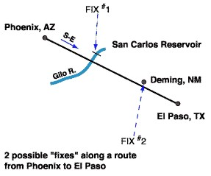
measurement
Knots and Nautical Miles
All navigation uses the Nautical Mile as the unit of distance. Traditionally a nautical mile is 6,080 feet but more precisely 6,076.11549 feet. In metric measurement it is 1,852 meters, which is one minute of arc of a great circle of the Earth. Even under the metric system, the unit of distance for navigation is still called the nautical mile. One knot converted to miles per hour (mph) would be approximately 1.15 mph. One mile per hour would be 0.868 knots. A statute mile is the common "mile" with a length of 5,280 feet. Therefore a statute mile is not as long as a nautical mile. One nautical mile would equal approximately 1.15 statute miles. Making the conversion from nautical miles to statute miles would be done as 120 nautical miles x 1.15 statute miles = 138 statute miles. Converting from statute to nautical miles would require dividing by 1.15. Therefore 200 statute miles would equal (200 / 1.15 = 174) 174 nautical miles.
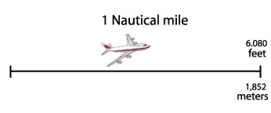
Many of the air navigational terms come from our heritage of sea navigation. In the days of wooden sailing vessels, the speed of a sailing ship was measured by unravelling a knotted rope into the water behind the moving ship. The number of knots in the rope that passed over the railing in a given amount of time would indicate how fast the ship was moving (its number of knots). It is this same term that is used in aeronautics and aviation to indicate flight speed, however without the knotted rope trailing behind the aircraft.
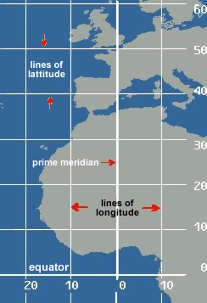
Latitude / Longitude
A reference system is used with which an exact location on the Earth's surface can be pinpointed. This system uses designated lines of latitude and longitude. Latitude measures north and south of the equator, and longitude measures east and west of the prime meridian (located in Greenwich, England). The latitude of an exact location is expressed in terms of degrees, minutes and tenths of a minute. One minute of latitude equals 1/60th of a degree. The North Pole, for example, is 90 degrees north of the equator. This is written as N9000.0. The South Pole is located at 90 degrees south of the equator and is written as S9000.0. The longitude of an exact location is expressed in terms of degrees, minutes and tenths of a minute, also. One minute of longitude equals 1/60th of a degree. The longitude of the airport at Miami, Florida is located, for example, approximately 80 degrees west of the prime meridian. Precisely, this is written as W08016.6, and expressed as 80 degrees and 16.6 minutes west of the zero meridian. The airport at Perth, Australia is located approximately 115 degrees east of the zero meridian and is written as E11557.5. This is expressed as 115 degrees and 57.5 minutes east. Combining both latitude and longitude, the location of the airport in Miami, Florida is N2547.1 and W08016.6. This measure is used globally and communicates clearly to all pilots the same locations.
Compass Directions
In navigation and surveying all measurement of direction is performed by using the numbers of a compass. A compass is a 360° circle where 0/360° is North, 90° is East, 180° is South, and 270° is West.
Each runway has a different number on each end. Look at the diagram below. One end of the runway is facing due west while the other end of the runway is facing due east. The compass direction for due west is 270 degrees ("27"). The compass direction for due east is 90 degrees ("9"). All runways follow this directional layout. This runway would be referred to as "Runway 9-27" because of its east-west orientation.
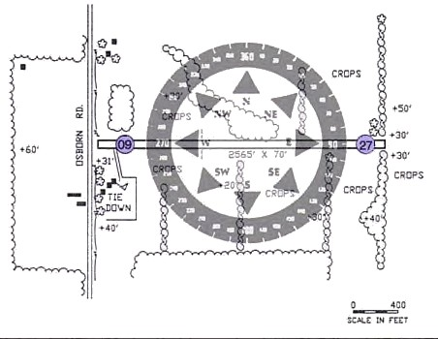
Applying this to navigation means that pilots do not turn right or left, or fly east or south exactly. To fly east the pilot would take a heading of 90° . To fly south, the compass heading would be 180°. Look at the compass below to note the compass headings for northeast, southwest and west.
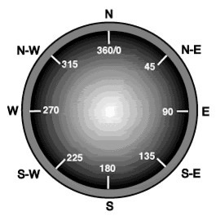
calculations
Air Speed / Ground Speed
Taking a 60 mile long road trip by car, the driver is fairly sure that if the average speed is 60 miles per hour (mph) for the trip, then it will probably take approximately one hour for the trip (60/60 = 1). This would not be as certain with an airplane because of wind. An airplane's speed can be greatly enhanced or diminished by the wind. This is the reason for the consideration of 2 speeds: ground speed and airspeed. Ground speed is the speed at which an airplane is moving with respect to the ground. Airspeed is the speed of an airplane in relation to the air. (Think of airspeed as the speed at which its propulsion system is set to move it along.) If an airplane is flying with the wind then its ground speed will be enhanced. That means its ground speed will be faster than its airspeed. If an airplane is flying against the wind then its ground speed will be reduced. That means its ground speed will be slower than its airspeed. If an airplane is flying through still air (air with no measurable wind), then its ground speed and airspeed will be the same.
Look at the picture below.
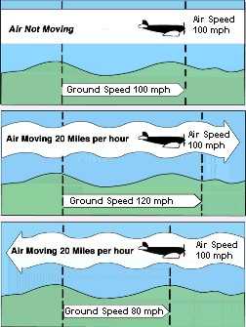
Vectors
The term "vector" is used to describe a course flown by an aircraft. Pilots ask for and air traffic controllers issue a heading or a "vector". A vector quantity represents something that has magnitude and direction. Velocity is an example of a vector quantity. When flying, the pilot needs to know the aircraft's speed and direction. These combine to form a vector that represents velocity. Vectors are represented on a graph using a line segment drawn to scale to show the magnitude (in this case the aircraft's speed). An arrow is placed at the terminal point to indicate the direction of the course. The arrow also differentiates the initial point (starting point) from the opposite end (terminal point). Vectors represented on a graph with the same length and direction are considered to be equal.
Using vector addition you can compute the result of two forces that are applied at the same time to an object. Vector addition is used to solve navigation problems when airplanes fly through moving air. The result of vector addition depends on both the speed and direction of an aircraft's course as well as the wind vector. In the example below, we will consider the effects of the force of an airplane and the force of the wind. Vectors can be represented geometrically using a coordinate system.
For years, pilots have learned to solve wind correction problems graphically by plotting the vectors using paper, ruler, and protractor. Let's take a look at an example. Imagine an aircraft is flying with a heading of 45 degrees and a speed of 100 knots. A 20-knot wind is blowing due south. What will be the aircraft's groundspeed and course?
We can plot the velocity through the air as a vector with the length of the vector indicating the airspeed and the angle of the vector (measured from north) as the heading.
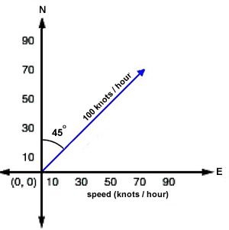
Now imagine that the aircraft is flying through a wind blowing due south at 20 knots. We can plot this as a vector with a length corresponding to 20 knots and pointing straight down. Since we want to add these two vectors together, plot the wind vector so that its tail is at the head of the heading vector.
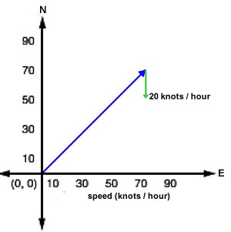
The sum of these two vectors will give the aircraft's direction and speed across the ground. You can simply draw the new vector running from the tail of the heading vector to the head of the wind vector. Its direction can be measured with a protractor, and the speed can be determined by measuring the length of the vector with a ruler. In this case, we measure a groundspeed of about 85 knots and course of about 55 degrees.
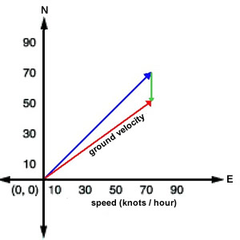
If you know some trigonometry, you can quickly and accurately solve this problem without any drawing or measuring. We know that there is a 45-degree angle between our heading and the direction of the wind. We can combine this with the airspeed and windspeed and the law of cosines to find our groundspeed.
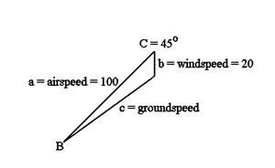
c² = a² + b² - 2ab(cosC)
c² = 100² + 20² - 2(100)(20)(cos45)
c = 87
Now that we know our groundspeed, we can use the law of sines to calculate how many degrees we will have to add to our heading to get our course across the ground.
sin B = b (sin C)/ c
sin B = 20 (sin 45)/ 87
B = 9.4 degrees
Adding this angle to our heading gives a course of 54.4 degrees.
Flight Distance
Calculating flight distance on an aeronautical chart is perhaps simpler than planning a driving route on a road map. On the aeronautical chart locate your departure and destination airports. Using a series of straight lines, plot a course from the departure point to the destination point bearing in mind the following:
Flight restrictions for your aircraft (altitude, fuel tank size)
Physical obstructions (such as heights of buildings, towers, mountains, mountain passes)
Other restrictions (such as restricted airspace, restricted airways, assigned airways)
Aeronautical charts usually use as a scale of 1:500,000 (or sometimes written 1/500,000). This means that 1 single unit on the chart (which could be inch, foot, yard, statute mile, nautical mile or kilometre) represents 500,000 of that same unit on the ground. So, if the aeronautical chart uses inches, then 1 inch on the chart equals 500,000 inches on the Earth. Check elsewhere on the chart to see the conversion scale of chart distance to statute or nautical miles. The smaller the scale of the chart, the less the detail can be shown on the chart. With chart measurements being equal, a 1:250,000 scale will provide greater detail than a chart with a scale of a 1:1,000,000 because the first chart will cover a smaller amount of area.
Using the conversion scale as indicated on the aeronautical chart, calculate the total number of miles to be flown by multiplying the total number of inches measured by scale of miles to inches.
Flight Time
Flight time indicates the actual time an aircraft is in the air flying from its departure point to its destination point. The computed flight time is a simple equation of T = D/S or Time equals Distance divided by Speed. Convert the decimal answer to our 60-minutes-to-an-hour and the flight time will be expressed in hours and minutes.
Let's say for example, that a pilot will fly a small Cessna aircraft a distance of 560 miles. The airplane will have an average airspeed of 130 miles per hour moving with the wind which is blowing at 30 mph. How long will the flight take? Take the total number of miles and divide it by the ground speed (airspeed + or - wind speed). The quotient will give the pilot the flight time. Doing the calculation: 560 / (130 + 30) = 560 / 160 = 3.5. Since there are 60 minutes in an hour, the decimal .5 will need to be converted to our 60-minutes-to-an-hour clock.
To do that, take the answer 3.5 and convert as shown below:
3.5 = 3 + (.5 x 60 minutes) = 3 + 30.0 = 3 hours and 30 minutes
What if the pilot in the example above is flying against the wind? Calculating flight time would look like this:
560/ (130 - 30) = 560 / 100 = 5.6
Then convert the answer to minutes:
5.6 = 5 + (.6 x 60 minutes) = 5 + 36.0 = 5 hours and 36 minutes
Fuel Requirements
The pilot of the aircraft makes the decision of how much fuel to carry based upon the following information:
Aircraft operations handbook's specifications for fuel consumption, weight and balance
Payload weight (cargo, baggage and passengers)
Weight of fuel (number of gallons x 6 pounds = total weight of fuel in pounds)
Weather and winds
Total distance of flight
Average flight speed
Number of miles per gallon averaged by the aircraft carrying the weight for this flight
Typically there is a legal minimum fuel limit that all aircraft must follow when determining how much fuel to pump into the tanks. The minimum amount of fuel required needs to be able to fuel the following:
the aircraft from its departure airport to its destination airport
being able to carry out an approach and go-around
flying to an alternate airport nearby (in case there is weather impediments at the scheduled destination airport)
the ability to fly a 30-minute, holding pattern above the alternate airport land and taxi to the gate
To calculate the amount of fuel needed for a flight, the pilot uses the following equation:
Fuel Flow (gallons per hour) x Time = Fuel Consumed
The pilot uses charts found in the aircraft operation handbook that provides information about the miles per gallon of the aircraft at certain weights. The weight of the fuel is calculated by taking the total number of gallons and multiplying it by 6 pounds. One gallon of fuel weighs 6 pounds. This is usually figured into the charts found in the handbook.
Once the pilot knows the aircraft's fuel consumption rate for the weight being flown and the flight time, the pilot can compute the fuel needed for the flight.
Look at the example below.
8.5 gph (fuel consumption rate) x 1:40 (flight time in hours/minutes) = 14.2 gallons
The pilot of this aircraft will need to make sure that at least 14.5 gallons of fuel are pumped into the fuel tanks for this flight.
Fuel Consumption
How much and how fast an aircraft uses fuel is known as fuel consumption. The same calculation used for determining a car's fuel consumption is also used for an aircraft with additional consideration for the weight of the payload (passengers and/or cargo). All aircraft have an operator's manual that gives specifications such as fuel consumption at different payload weights and fuel amounts. Remember the weight of the fuel also needs to figure into the equation! For example, let's say a small aircraft has a speed range of 120 - 170 mph and holds up to 40 gallons of fuel. Let's say that according to the aircraft's specifications at full payload and fuel weight the aircraft uses 10 gallons of fuel per hour. Take the total amount of fuel (40 gallons) and divide that by the number of gallons used per hour (10) and you will find that the aircraft could be flown for 4 hours. Remember that a good pilot will never fly on fumes, and would stop for re-fuelling long before the 4 hours are up.
Now let's say that the same aircraft is flying with a full tank of fuel, but only half its full payload weight. According to the fuel consumption specifications for this aircraft it will use 8 gallons of fuel per hour. How long will it be able to fly? Do the math: 40 gallons divided by 8 gallons per hour will provide a little over 5 hours of flight time.
True North / Magnetic North
All aeronautical charts are drawn using True North. All airport runways, however, are marked by their magnetic compass directions to the nearest 10°. Runway 5-23 at an airport is a Northeast - Southwest runway. It means if an airplane lands from the SW heading NE on runway 5 the magnetic compass in the airplane would be showing about 050° for the heading. The difference between the magnetic direction and the true direction is called the magnetic variation. All aeronautical charts show the magnetic variation. To convert from a true to magnetic direction many pilots use the saying "East is least, West is best." This serves as a reminder that one subtracts an eastward variation from the true course to get the magnetic course. Inversely, one adds a westward magnetic variation to the true course to get the magnetic course. For example, if the magnetic variation is 15 degrees 30 minutes East, after plotting one's true course, the magnetic course would be the true course minus 15 degrees 5 minutes. Pilots also use the saying "North lags and the south leads." This serves to remind pilots that if he or she turns the airplane from a northerly course the compass first indicates a turn in the opposite direction, then lags behind the actual compass heading. This means that when a pilot rolls out of a turn to a different heading, one must roll out before the compass reads that desired heading. Otherwise the new heading will be a few degrees more than desired (which would eventually lead one way off course). When turning from a southerly heading the compass leads initially, then shows the desired heading before actually reaching that heading.
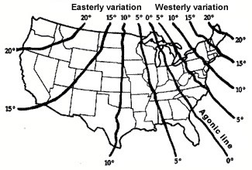
Another compass error is caused when the airplane is accelerated. The compass indicates a turn to the north. When the airplane decelerates, the compass indicates a turn to the south. From this comes the pilot saying: "Accelerate north, decelerate south." Pilots and air traffic controllers need to be aware of such variations, so as to maintain a proper course at all times.
At many airports the compass variation can be significant. In Anchorage, AK the variation is 25° East while in Dallas, TX the variation is 6° East. However, Nashville, TN the variation is only 1° West.
aeronautical charts
Aeronautical charts provide important information to the pilot. Sectional charts show topographic details, relief features and aeronautical information of the selected area and are updated regularly. Other types of charts display routes, airways and ground terminal locations.
The direction and distance come from a map or chart. To navigate when driving a car one uses a map with printed routes, and you verify your position using landmarks and signs posted along the way. For air navigation your intended course is plotted on a map or chart and your position is verified along the way with any number of interesting methods. By the way, a chart is a map on which you plot a course.
An aeronautical chart provides pilots with a representation of a section of the Earth's surface (hence their name "Sectional Chart"). This section shows many of the same features on a road map. These emphasize landmarks and other special land features that would be easy for pilots to spot from the air. It delineates cities, tall structures, geographical features and major roads. It is also color-coded. Yellow areas depict cities, green areas indicate hills, brown is used to show mountains and magenta denotes roads. The intensity of the colour corresponds to the object's height. The greater the intensity of the color, the higher or taller the object. These charts are updated and revised every six months. Pilots are encouraged to plot their course using the most recent and updated chart.
The aeronautical chart is designed for convenient navigational use by pilots. It is intended to be written on and marked up as needed by the pilot to plot the course and/or solve navigational problems such as calculations of direction and distance.
Sectional Chart
The scale of a "sectional" is 1/500,000 so one inch is about seven nautical miles. It usually gives enough detail to fly by ground reference or pilotage. A sectional shows highways and railroads, power transmission lines and television and radio towers. It shows lakes, quarries, race tracks and other landmarks. Sectionals also show information you cannot see on the ground such as Prohibited, Restricted, Warning, and Alert Areas that have their own special flight rules. Sectionals show Federal Airways commonly known as Victor Airways that are highways in the sky connecting Very High Frequency Omnirange Stations (VOR) stations. A sectional also shows topography or relief using contour intervals and color differentiation. Blue indicates the lowest elevations and brown indicates the highest. The highest obstruction in an area bounded by latitude and longitudes are shown with a numeral for thousands of feet with another numeral as a superscript for hundreds of feet. The highest terrain elevation is shown on the front of the chart. Isogonic lines showing Magnetic Variation are also shown on a aeronautical charts.
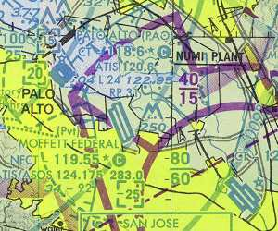
World Aeronautical Chart (WAC)
WAC charts scale is 1/1,000,000 making one inch about fourteen miles. Since WAC charts cover a larger area not as much detail is shown. WAC charts are used for flights of long distances.
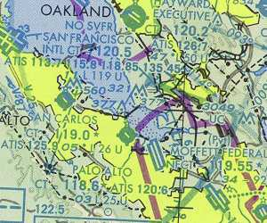
VFR Terminal Area Chart
If you plan to fly in or near a large metropolitan area a VFR Terminal Area Chart may be available. A VFR terminal Area Chart has everything a sectional chart has but in greater detail. The scale is 1/250,00. Open circles with points at the top, bottom and both sides show VFR way points. Flags indicate a visual checkpoint. An air traffic controller may tell a VFR pilot to report over the golf course for instance. The golf course will be indicated on sectionals and VFR Terminal Area Charts with a flag icon. Small black squares indicate easily identified places on the ground.
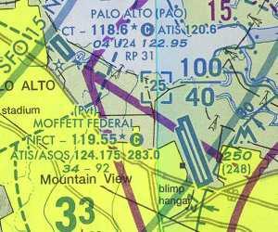
IFR Charts
If the flight will be flown under instrument meteorological conditions, there are two types of instrument charts. Pilots also have to file an IFR Flight Plan to fly in IMC conditions.
En Route Low Altitude Charts are used for IFR flight planning by most propeller driven aircraft flying below the higher flying jet aircraft. Low altitude charts show Victor Airways, minimum altitudes, distances, magnetic courses, reporting points, and related data.
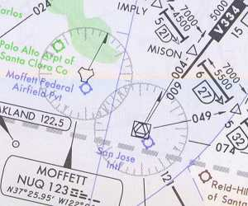
En Route High Altitude Charts portray Jet routes, distances, time zones, special use airspace, radar jet advisory areas, and other data. IFR flight plans are necessary for all flights above 18,000 feet.
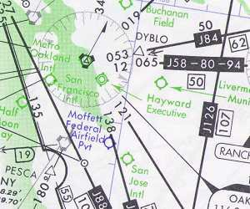
reading a sectional chart
Sectional Charts are meant to only show a section of a flight region. These charts emphasize only landmarks and features that would be important to a pilot for navigation during flight. Tall, man-made structures and natural landmarks are indicated along with roadways, rivers and railroad tracks, as these are easily seen and recognized by pilots from the air. Topography is referenced by a special colour code with lightness or darkness of the colour indicating a lower or higher in elevation of the land.
Take a look at the Sectional Chart below and notice how much information it communicates to the pilot. We'll break this Sectional Chart down into layers, so you can easily see how the many important features are noted on the chart. Check the button for any given layer to view that layer; uncheck it to hide the layer. Select any combination of layers to place them together, so you can view the sectional chart in different ways.
There are a number of important components to this chart. Let's examine them in detail.
Elevation
Notice the use of colour to show elevation. The colour code is given in the box next to the chart. Remember, the darker the shade, the higher the elevation. The lighter the shade, the lower the elevation. Bright yellow indicates a city.
Topography
This layer shows the man-made and natural features that would be easily visible to a pilot during flight. The man-made features include tall towers, roads, railroad tracks, dams, outdoor theatres, race tracks, bridges, lookout towers, power transmission lines, aerial cables, and coast guard stations. The natural features include lakes, rivers and mountain passes.
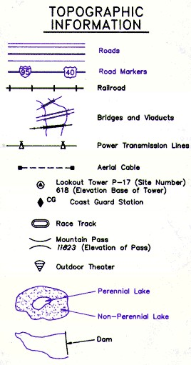
Obstructions
These man-made structures are usually tall radio towers, simply tall towers or they are very tall structures that are not specifically identified on the map. See the key below.
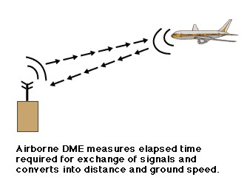
Airport Information
An airport is indicated by the type and length of runway it has. There are also special symbols to indicate if the airport is restricted in any way, if it is a military airport, if it has been abandoned and if it provides services such as fuel. Airports having control towers are shown in blue. Additional data about the airport is given in a blue-lined box. All other airports are shown in magenta. For specific details about an airport, the pilot needs to consult the Airport Facility Directory. Click the key below for a closer view.
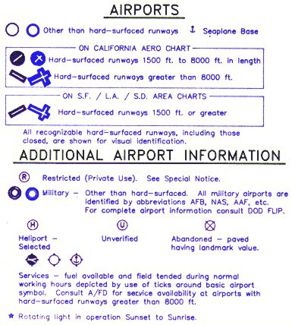
Airport Data
The blue-lined box gives details about the airport indicated in blue. (Remember blue airports have control towers!) This data can be lengthy or brief and usually includes radio frequencies, elevation, runway length and lighting availability. Click the key below for a closer view.
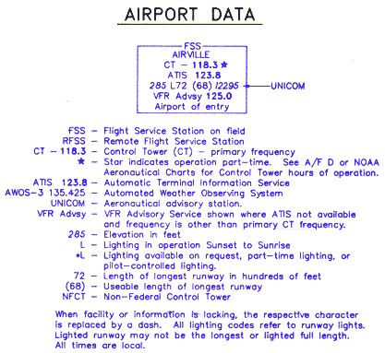
Radio Aids
The symbols listed in the box below inform pilots as to what radio aids are available for their navigation. Click the box for a closer view.
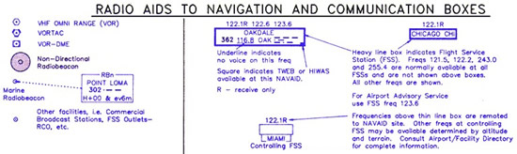
Airspace Information
The type of aircraft being flown will determine the airspace in which it should be flown. The floor and/or ceiling for each different airspace designation is sometimes indicated on the chart. Airways, departure and arrival routes are also drawn on the map. Restricted areas and military operation areas are boxed in blue or magenta. Click the box below for details.
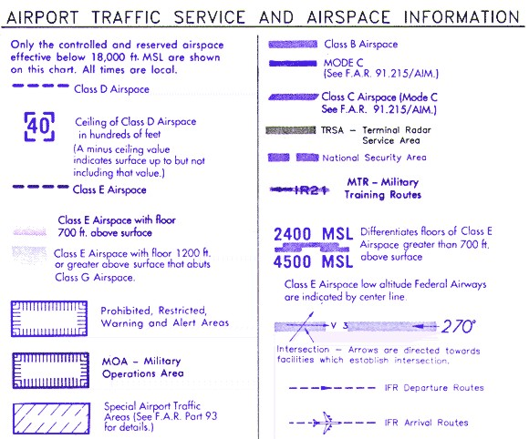
Miscellaneous
These symbols show special activity that can occur in a certain area such as ultra-light flying, hang gliding, parachuting and glider operations. If an airport has a flashing beacon, it is also indicated. See the key below for these symbols.
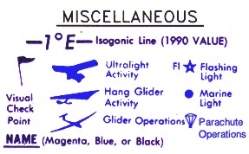
Text
All names are printed in black, blue or magenta and can indicate cities, mountains, rivers and regions.
Compass
Throughout a sectional chart a compass rose is placed to identify to the pilot the orientation to the cardinal points (north, south, east and west).
airways and aircraft separation
In order to keep air traffic flowing smoothly and safely, the nation's air traffic management system has for years been using "airways" in the sky. An airway is a designated space of air through which aircraft are directed to fly by air traffic control. Above 18,000 feet they are referred to as jetways. Picture these as large imaginary traffic lanes or corridors in the sky. This ensures that air traffic travelling in one general direction moves smoothly through the controlled airspace system maintaining a safe distance between each aircraft by having them fly at certain flight speeds and flight levels or altitudes.
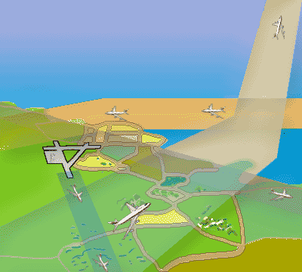
These airways are indicated on aeronautical charts and are used regularly by all aircraft large and small flying through controlled airspace. When flying cross-country on a commercial jetliner, that aircraft is actually one aircraft in a line of aircraft heading in the same general direction at the same altitude. This is much like cars on the highway travelling at the posted speed limit while maintaining a 3-carlength distance between the car in front and the car behind while driving along a one-lane highway.
Separation of Air Traffic and Rules
As in all aspects of life there are rules and regulations that affect flying. Some rules are just good common sense practices while others are habits acquired through specific training. All of these rules exist because safety in the skies is the most important consideration of all.
There are some basic flying common sense rules in which all pilots and air traffic controllers are trained. Some are given below.
Spend 70% of pilot time scanning the skies using a series of short, regularly spaced eye movements in 10° sections alternately looking both near and far, horizontally and vertically.
If there is no apparent motion between the aircraft you are piloting and another aircraft, then both are probably on a collision course.
Be aware of your aircraft's blind spots.
Before beginning a manoeuvre, make clearing turns while carefully scanning the area for other aircraft.
When faced with an aircraft approaching head-on, both aircraft are required to alter the course to the right.
When overtaking another aircraft flying in the same direction and on the same course, the aircraft being overtaken has the right-of-way, therefore pass well clear of it on the right.
When two aircraft are converging or approaching from the side, the aircraft to the left must give way to the aircraft on the right.
A general right-of-way rule states that the least manoeuvrable aircraft has the right-of-way.
Over congested areas (city or metropolitan area), aircraft are required to fly 1,000 feet above any obstruction (tall building, for example) within a horizontal radius of 2,000 feet of that aircraft.
Over un-congested areas (rural land, not open water), aircraft are required to fly at least 500 feet above the surface.
For most small aircraft flying outside controlled airspace in good weather, the pilots are responsible for maintaining a safe distance from other aircraft. This is the "see and be seen" principle otherwise known as VFR or Visual Flight Rules. In this mode of operation, a pilot must keep a continual watch for other aircraft in the sky. When flying above 3,000 feet above ground level (AGL), the pilot must follow VFR cruising altitudes given below (or east/west cruising altitudes). The pilot may set his/her altimeter to a standard barometric pressure of 1013mb (29ins mercury). If this is the case, at an altitude of over 3000 ft, the pilot is flying at flight levels. Other aircraft flying at flight levels also have the same altimeter setting, thus there is an accurate separation.
In some countries, such as the USA and France aircraft remain separated as shown below:
Flying a magnetic course of 0° - 179°, fly at odd thousands plus 500 feet. For example, 3,500; 5,500; 7,500.
Flying a magnetic course of 18° - 359°, fly at even thousands plus 500 feet. For example, 4,500; 6,500; 8,500.
In the UK, the levels are divided up into four sectors.
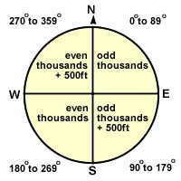
For jetliners flying inside controlled airspace, pilots are still responsible for maintaining a safe distance from other aircraft. They also must strictly follow IFR or Instrument Flight Rules. In this mode of operation, pilots are flying under reduced visibility and must depend on their instruments for additional guidance and information. Though rules of separation vary depending on the airspace in which a jetliner is flying, in general, air traffic controllers and pilots are required to maintain a horizontal distance of 5 nautical miles between 2 aircraft flying at the same altitude. For altitudes at and below 29,000 feet, vertical separation must be maintained at a minimum 1,000 feet. For altitudes above 29,000 feet vertical separation must be maintained at a minimum of 2,000 feet.
navigation by G.P.S
GPS as an illicit substance and how to handle it without sinking into total dependency.
... if you can confine your habit to one of moderation, you may survive and even prosper ...
reproduced from GASCO
For my part I use GPS all the time that I am flying outside my local area and regard it as something almost magical in its ability to solve navigational problems that used to take much cudgelling of an overtaxed brain. What is your estimate for DUNNO?. an earnest controller would ask. After the initial wave of panic and the shaming response. Standby, (It is written that every proficient navigator must always have to hand their estimate for the next three waypoints - so what sort of navigator does that make me'?) I would then embark upon a tortuous mental calculation that went something like:
My groundspeed is about 10' KTS and I should think that I am about here (or might it be there?) If my first position is correct there is about 21 miles to DUNNO but if it is the second it is only /6 miles: I shall make a masterly compromise at 18. So it's 18 miles at 107 KTS and Time equals Distance over Speed (or is it the other way around?). So 18 over 107 equals ...God Knows. lf it was 107 over 18 it would work out at about five or six. But the answer must be in hours as knots are nautical miles per hour. It ' can't be five or six hours. Or can it? Well anyway - I do know that ' if I was flying at 120 KTS it would be half of 18 in minutes. That's nine minutes from when l was at where I thought that I might be and that was at four minutes to and so my estimate should be a bit after five minutes past. Say six minutes past. Past what? lf it's now two minutes to twelve, French time, what's that in Zulu?
And so on. Such an innocent request from a controller can take all the fun out of flying. These days I simply consult my GPS and instantly respond: ', 10 minutes from now. However, everything brings ', its own price and with GPS it is the risk of total dependency. Yes, we are into illicit substances here.
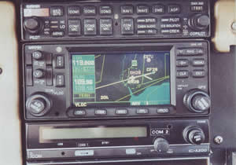
A Garmin 430. Common equipment for IFR aircraft
That nice avionics salesperson tempts you with such an attractive little proposition. For about £300 you can have a proper aviation hand held set and for half that a non aviation set that will be just as accurate, but will not know where EGLL is unless you first tell it. Give it a try, you'll like it! Says the helpful salesperson, and by golly, you will like it. In no time at all you will be venturing out to distant places and scraping home in low scud confident that your little friend knows just where you are, even if you don't. Before long the craving will be luring you into moving maps, colour, terrain and all the bells and whistles.
The thing is that if you can confine your habit to one of moderation, you may survive and even prosper, but if you let it take you over, so that you become a total dependant then, sooner or later, doom awaits you. Doom in this instance will take the form of your finding yourself overhead EGLL (London, Heathrow) when your magic little friend has definitely assured you that you were nicely on track from Popham to Biggin Hill - well, 0.3 miles right of track, to be precise.
In nine cases out of ten, it is not actually your little friend's fault but yours. You entered some nonsense into the set and it just did what you said. The most common fault is to get one of the 15 digits that make up a lat/long co-ordinate wrong. Or you might have meant to enter EGKB (Biggin Hill) as your destination but absentmindedly entered EGSG (Stapleford). Mistakes of this sort are easily and often made. Much less often, it's your little friend lets you down. It runs out of batteries or satellite signals and dies on you. At least you will then be aware that all is not well but very occasionally it will mislead you in spite of your fingers having pressed all the right buttons and in the right order too.
Thus, you cannot rely totally on GPS because occasionally it will mislead you. Consequently you must always run some other navigation system as a check, which is a bit of a pain when you thought that all your navigation problems had been solved. Nonetheless, if you are to avoid all the unpleasantness that follows busting controlled airspace, you have to keep running that check.
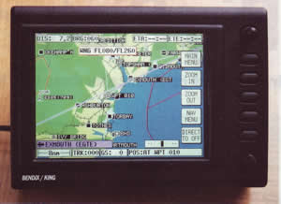
A Bendix/King Skymap Ill. Easier to use and less error prone than earlier or simpler sets
For IFR pilots your check system will probably be VOR/DME and if you have an RNAV set it will mean merely entering your waypoints in your RNAV set as well as your GPS set and making sure that both sets are giving you the same information. Without RNAV you will need to check VOR/DME co-ordinates from time to time.
For VFR pilots, I'm afraid it's back to the old map reading, watch and compass. Here are a few tips:
1 Enter the route in your GPS set the night before. This gives you time to draw track lines on your map, construct your PLOG, check that you have entered your waypoints correctly and familiarise yourself with your GPS set once more. If your set is panel mounted, get a software simulator of your GPS for your PC and set up the route on that the night before.
2 Avoid lat/long co-ordinates and use instead bearing and distance from somewhere already in your database. Thus if, say, the south western end of the twin canals in Cambridgeshire is a waypoint, it is much easier to define and enter this as 001 deg and 22 nm from BKY than it is to deal with N522133E0000215. Furthermore, in the air, when the brain atrophies, 22 miles North of Barkway means something that you can quickly check, while those 15 co-ordinates mean nothing.
3 Choose waypoints and routes that are easily recognisable from the air, even though that means creating User Waypoints.
4 If you can use a 'second generation' GPS set, such as a Bendix/King Skymap III with a large moving map and a joystick for moving a pointer around so as quickly to define waypoints, you will be considerably less error prone.
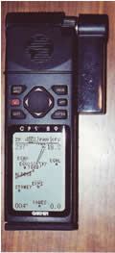
A handheld GPS set
If you keep your visual navigation going alongside your, GPS nav. you will soon detect when things are not as they should be and in this way you will cleverly avoid the dreaded consequences of over dependence. If you also keep in contact with a controller providing a Radar Information or Flight Information service they can often save you from the error of your ways before things get serious. With GPS, plus a visual nav. check plus an information, service your navigation should be foolproof.

